VIETNAM

Phu Cat Sunrise!
© 2004 by Thomas "Tom" Aumack, Sgt.
(MSgt-Ret, USAF )
Phu Cat Air Base, 37th SPS and 12th SPS
March 1970 - March 1971

Recently I visited the VSPA site for the first time. What an excellent job is being done on the site. I read the stories about Phu Cat, Air Base, reviewed pictures, and recalled the searching for SSgt Wissig and Airman Davis, our fallen comrades. They brought back memories.

I took special interest in the story "Vietnam … Dawn, Thanks for the Sunrise" by Harold Throne. I was an early participant, shortly before dusk, in the in the security set up for the M-113A1 Armed Personnel Carrier (APC) that was disabled in the river near the ROK Water Point in October 1970.

Photo: Airman "Snowman", on an APC in use at Phu Cat AB, 1968.

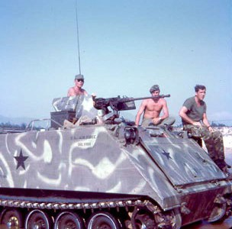

I was a Sergeant assigned to Cobra Flight and the track commander of Charlie 7, a two-man APC response force. Charlie-7 normally set up just outside the Civil Engineering yard by the Main Gate where the rail car gravel dump was located and downhill from the POL yard. Our role was that of a two-man blocking force with ammunition re-supply capability. During periods of increased security, we picked up additional members and became a Quebec Team (six-man blocking force).

The October night in question a runner summoned my gunner and me to report the Guardmount/armory area. We were told we were going to be needed to try and pull a track out of the river. I contacted my gunner and we responded.
At the armory we were directed to arm up and proceed to the "hole" in the fence, the access road from base to the ROK Water Point. A Security Alert Team (SAT) was there and Captain Kelly, Cobra Flight OIC, arrived to brief us.

The situation briefed was that a team had taken an APC past the main line of resistance (MLR) on a training mission. During the training mission the crew had tried to ford the river to the West of the Air Base. While crossing the river, which was running swift, the current carried the APC down river. Near the water point, the rear of the APC contacted a sandbar in the river, which forced the exhaust and intake grills at the front of the APC
under water. This flooded the engine compartment and caused the track to sink. The APC came to rest across the river from the water point.

We proceeded to the water point. South of the water point was a depression to the right of the trail that led down to a small clearing at the edge of the river. I was directed into the clearing about 75 yards from the water point perimeter. In the dwindling light, the situation was surveyed, and someone thought someone could swim a chain over to the other side of the river and hook it up to the APC and my APC could pull them across. Given the swiftness of the current combined with the weight of a chain that plan was quickly scrapped. So was the thought of swimming a rope over and dragging a chain across the river.

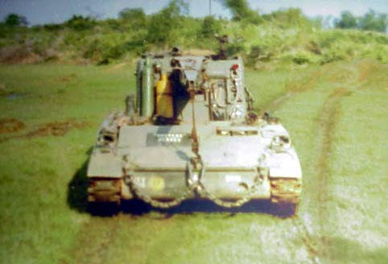

Photo: Tank Retriever arrives by land and prepares to enter the river to retrieve the APC.
The concerns, even if a chain could be made to the APC and hooked up were:
- The APC was not going to float.
- No one knew how much the water-logged APC that was 13 ½ tons combat loaded
would weigh.
- No one knew how deep the river was, or, if it was even possible to drag the APC
across the river.

As I recall, there were five or six men on the track and probably 2/3s of the top deck was under water, which provided cramped quarters. Everyone got wet and ended up very miserable.

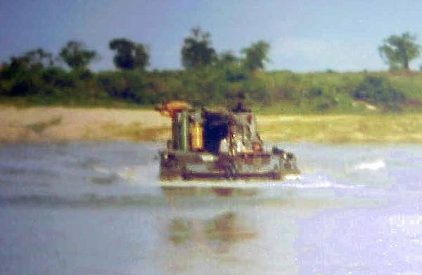
Photo: Tank Retriever on river.

Photo: Close-up of men on top of the Track, which is partial submerged.
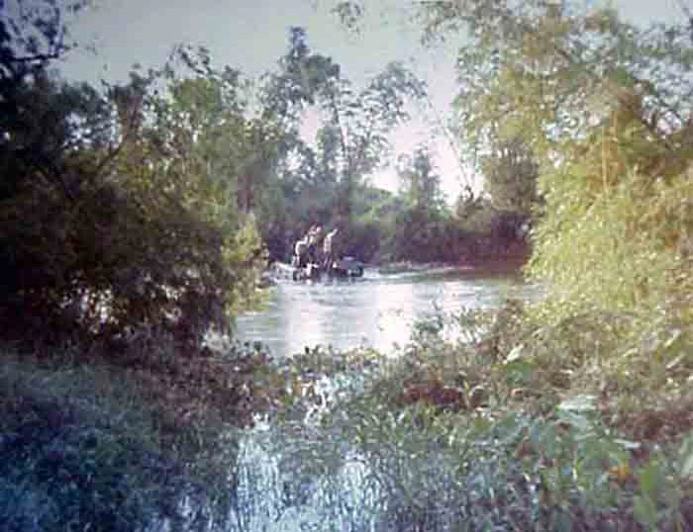

I was asked to try and throw cigarettes and a light across the river to the APC! Sometime between 2100-2200 hours, Capt. Kelly gave up hope of recovering the track or the crew that night. Charlie- 7 would stay in the clearing to provide cover and communication for the APC. The Sniper Ambush Team would be deployed to back us up. The SAT left and returned sometime later with a cooler of coffee, needed.
Photo: Men on top of sunken APC
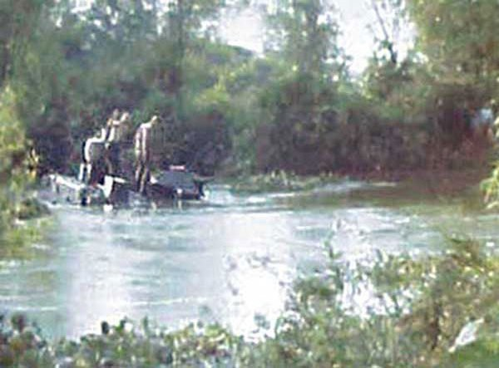

For the long night. The SAT team remained until the Sniper Ambush Team arrived and deployed for the rest of the night.
The things that stick out in my mind from that night was:

- The Korean on water point guard duty drove us crazy with his singing most of the night.
- The mad minute from the bridge 1 or 2 clicks South of us. My thoughts were if they had movement, their firing could drive the enemy towards our location.
- The discomfort of our comrades on the track.

I had all but forgotten about the group of airmen sneaking back to base.

For the Sniper Ambush Team, their thanks for the sunrise averted a friendly fire incident. My thanks for the sunrise brought an end to a long night without out losing anyone.

P.S. a tank retrieval unit recovered the APC that next morning.

Photo: NKP Thailand, M-113, tight quarters, with SSgt Sapio grinning.
Thomas Aumack, MSgt-Ret, USAF.
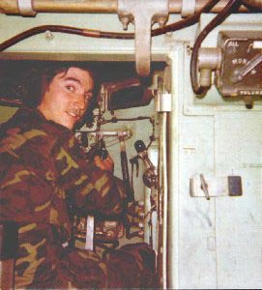

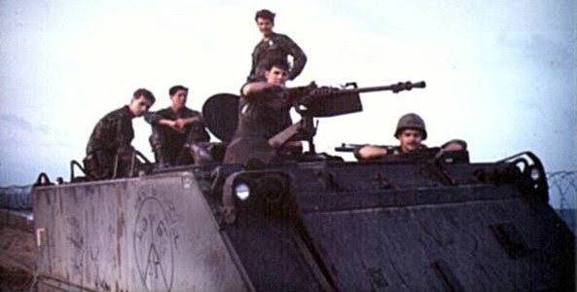
Photo: Airman deRussy on an APC at Tuy Hoa AB.

Thanks for the Sunrise

