Sapper Attack! Tan Son Nhut Air Base, 4 December 1966. William C. Trimble, VPA LM-465

Sapper Attack! December 4, 1966

377th Security Police Squadron, Tan Son Nhut, RVN
© 2009 by William C. Trimble, LM 465

"The head of a VC I was shooting at suddenly exploded and the man fell to the ground."
For ten minutes I was a dog handler in Vietnam!
On April 13, 1966, Tan Son Nhut AB received a Stand Off attacked with 246 Rockets and Mortars within thirteen minutes. Casualties: US KIA 7, WIA 111, RVN KIA 2, and with 9 destroyed aircraft and 62 damaged. NVA/VC KIA: 28, POW 4.

377th APS, Tan Son Nhut Air Base, Republic of Vietnam, 1966-1967

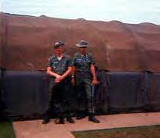
I was an Airman Third Class Air Policeman assigned to "A" Flight, 377th APS at Tan Son Nhut AB from September 1966 to September 1967. I was 19 years old and had been in country a little over 2 months. This is my story:

Photo left: AP Bill Trimble, left and unknown AP,1966.
It was Sunday, December 4, 1966. I had been relieved from post (A-10) at approximately 2030 hours the night before and after returning to the AP compound to turn in my weapon and equipment it was after 2100 hours before I got to bed.

I had been asleep for 2-3 hours when I awaken to someone yelling "fall out, we're under attack" and I heard explosions and machine gun fire coming from the vicinity of the flight line. I quickly got dressed and, grabbing my Helmet and web gear, ran (shirt unbuttoned and boot laces dragging) over to the armory to get a weapon.

After receiving an M16 I boarded a 1 ½-ton stake truck with 14 others, and we drove to CSC to determine what was happening and to find out where we should go.
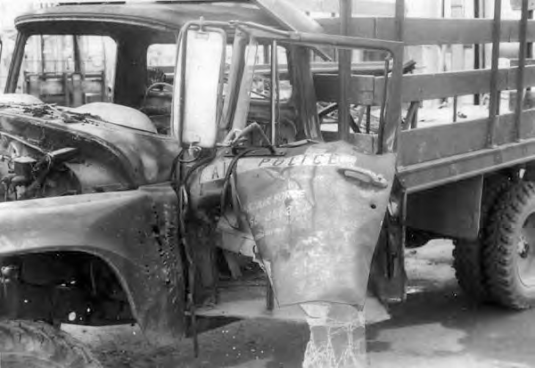
Photo Right: Ton & Half 377th Air Police Truck, battle damaged, 4 Dec 1966.

Reivised: 06/21 Vietnam Security Police Association, Inc. (UDAF) Page 1 of 5

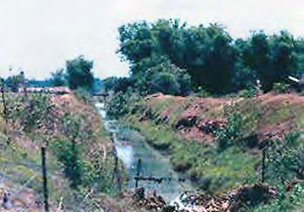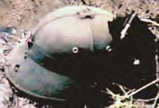
After a brief time, it was determined that we should go to the west perimeter and set up a blocking force
on the perimeter road just south of the ditch that ran under the perimeter fence between the runway and the counter-mortar battery. I was one of the last to dismount the truck once we were in position. The truck then moved north on the road and had traveled about 100 feet when it suddenly exploded, apparently hit by a rocket propelled grenade. Soon after getting into position on the base side of the road, we came under mortar and small arms fire. Suddenly there was a small explosion to my right and a scream. I turned to look in that direction and saw an individual run across the road and dive into the elephant grass. We fired into the area where the individual dived. Because of the mortars raining
down on us, someone decided that we should
change our position to across the road towards the perimeter and Photo: Utah Ditch, photo
set up positions there. Soon the mortars stopped and we were instructed to move back to our original positions.

After establishing our positions I heard birds in a tree just south of me outside the fence line start making a lot of noise as if they had been disturbed. I mentioned this observation to a senior member of our team and stated that I thought something was about to happen in that area. Sure enough a machine gun started firing at us from under the tree. Aircraft soon flew over and attacked that area and eliminated the threat.

We were soon joined by other Air Policemen and several ambulances came and went. None of us on the team had a radio so it was a mystery to us how we were getting help just when we needed it. It turned out that A1C James (Skip) Miller (LM 441) was in a Tower (A-15) near our position and could see what was happening and reported our actions to CSC and requested the help we needed.

We were under fire most of the night and as daylight came things quieted down. We were under the misconception that the attack was over, and we started to stand up and talk amongst ourselves when someone yelled "there's some over there" and shots rang out. I had been talking to another member of our team when I heard and felt a bullet pass between us, and we were about two feet apart at the
time. We spun around in opposite directions and fell to the prone position and started returning fire. The head of a VC I was shooting at suddenly exploded and the man fell to the ground. I heard a commotion to my right and turned in that direction to see a couple of APs working on an individual who had been shot. They were about ten feet from me. It turned out that that individual had been shot in the chest. A pen in his pocket had deflected the bullet enough that it missed his heart.

Soon the firing stopped, and two VC stood up with their hands in the air. We rushed up to them and took them
prisoner. After a sweep of the area, an all-clear sounded and we boarded vehicles to be taken back to the AP compound to get cleaned up, get something to eat and to rearm. Tables were set up with clerks to take our stories, however, I didn't get a chance to tell my story. "A" Flight was supposed to have a 0400 Guardmount that morning but it was delayed several hours because of the attack, so we had a quick Guardmount and went out to our assigned posts (A-10 for me). Shortly after being posted a tower guard reported movement on the northside of the runway. I was pulled off post to help in a
sweep of the area. One VC was found and killed on that sweep.

After our shift, I was assigned to the reserve alert team, and we were soon called out to again sweep the area north of the runway on the west side of the base.

Reivised: 06/21 Vietnam Security Police Association, Inc. (UDAF) Page 2 of 5

Sapper Attack! Tan Son Nhut Air Base, 4 December 1966. William C. Trimble, VPA LM-465
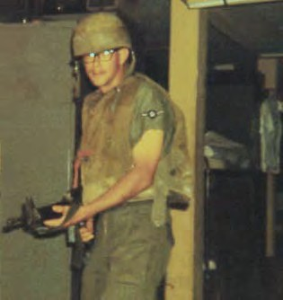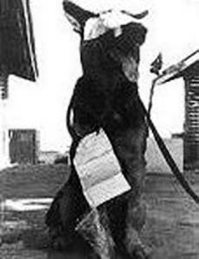

(Photo: Utah Ditch, photo left) Soon after starting our sweep, we came upon a ditch filled with waist deep water that we had to
cross. Some of the team members went into the water. I saw an area to my right that appeared dry and mover over to cross there. I had started across and was about half way when the "surface crust" broke and I sank up to my armpits in the mud and had to be pulled out. There was sporadic gun fire all around us for the next couple of hours. When the "all clear" was sounded we made our way out to the perimeter road for pick up and return to the alert hut. We recovered several VC bodies

along the way.
Photo right: A3C Bill Trimble, ready for Guardmount and mugging for the camera. Photos taken with my Kodak Instamatic camera.

All to soon it was time for Guardmount and back on post and live returned to "normal". I never did get a chance to tell my story to the clerks for the records and got no recognition for my part in defending the base. Many years later I read that the base had been attacked by two battalions of VC/NVA and that just outside of our position on the west perimeter the VC/NVA had established a blocking position of about 100 troops. They were there to protect their comrades as they infiltrated the base after the attack. I also read that our team was lead by TSgt Olbert Hiett and that out of the fifteen men sent out, two were killed
(A2C O. J. Riddle and A2C J. M. Cole) and nine were wounded.
I was one of four that came out of it alive and unhurt.

Photo left: Picture of USAF Sentry Dog, Nemo, shortly after he was wounded, 4 Dec. 1966.

saw an individual that I had gone through AZR with. He was Several days later as I was walking past the orderly room I a dog handler in the 377th APS K-9 Unit and was standing there with a Sentry Dog.

As I approached him he asked me to hold the dog while he went to use the restroom. I noticed that the dog had been heavily sedated and was covered in bandages, and I agreed. The dog had lost part of an ear and one of his eyes had a bandage over it. K-9's name was Nemo .

For ten minutes I was a dog handler in Vietnam! and as soon as I got back Stateside I put in a request for K-9 and was accepted, and the dog I was assigned was Kemo-- Nemo's older brother!

Reivised: 06/21 Vietnam Security Police Association, Inc. (UDAF) Page 3 of 5

Sapper Attack! Tan Son Nhut Air Base, 4 December 1966. William C. Trimble, VPA LM-465

Photo right: Picture of Kemo

Nemo and Kemo were assigned to Fairchild AFB in Washington State before Nemo was reassigned to Vietnam. Kemo was considered too old to be sent so remained at Fairchild. When I rotated back to the

States, 1967, I was assigned to Fairchild AFB and asked to be placed in K-9. I was assigned Kemo.

I don't remember Kemo's tattoo number. We were stationed at Fairchild AFB, near Spokane, Washington.
I had Kemo for six months then got promoted and had
to leave K-9 because there weren't any slots available for Bill Trimble, VSPA Life Member 465

77th Air Police Compound entrance. 377th Air Police Compound.

USAF Law Enforcement Helmet. 377th Air Police Sq, TSN. 1966.
USAF M1 Steel Pot Helmet with Cammie Cover. 1965- 1966. Vietnam and Thailand.

NVA Pith Helmet - KIA. NVA Pith Helmet - New.

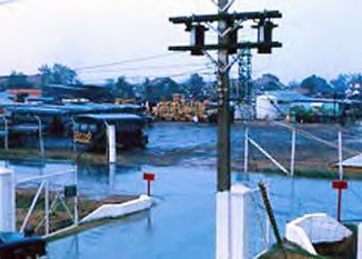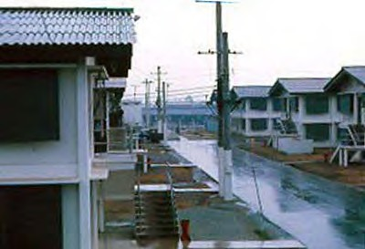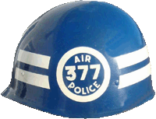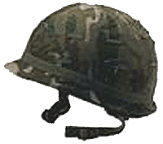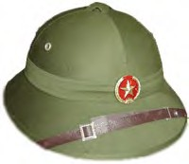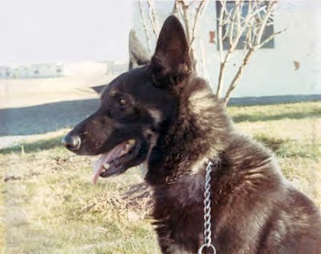
Bill Trimble and I were talking at the VSPA 2009 Reunion. Bill casually mentioned that upon return to stateside from Tan Son Nhut AB, in 1967, he joined K-9 and had a dog named "Kemo" -- Nemo's big brother! Being an old K-9 handler I immediately began scratching behind my ear with my foot and prompted Bill to pray- tell more! I asked if he had ever considered sending in his story of the 4 Dec 1966 Sapper attack, and including Nemo and Kemo's stories. He had not really thought about it but promised he would think it over and see if he could dig up some old photos. This is the story and photos almost lost from our history!

Thank you, Bill Trimble... your story is very important to a lot of old Air/Security Police, K-9 handlers, and today's Security Forces who followed in our paths. Don Poss
Reivised: 06/21 Vietnam Security Police Association, Inc. (UDAF) Page 4 of 5

Sapper Attack! Tan Son Nhut Air Base, 4 December 1966. William C. Trimble, VPA LM-465
Author: Bill Morris
Subject: Re: New Sapper Attack story posted!

Must-read for sure, including the "Stand Off and Sapper Attack on Tan Son Nhut AB, 4-5 Dec 1966." Interesting that "Kemo" was Nemo's older brother! Back in 1968 I saw Nemo at Lackland -- as many, many others had too....
Indeed, Nemo's story and that of his handler, A2C Throneburg, shall be remembered for all time, as will the three brave men -- A2C George M. Bevich Jr., A2C John M. Cole and A2C Oliver J. Riddle (RIP) -- who lost their lives during the attack. The three have their names on The Wall and I salute them and all the other brave fallen Americans.

Reivised: 06/21 Vietnam Security Police Association, Inc. (UDAF) Page 5 of 5

