Edwin "Jack" Smith
30 Dec 1947 - 19 August 2021
RIP

Edwin "Jack" Smith stood his final Guardmount at home today, surrounded by his family. Jack was VSPA Life Member #453 and served at Tan Son Nhut Air Base, Vietnam with his beloved 377th Security Police Squadron in 1968-69. Jack also served as a Vice President of the VSPA where he fostered the deep sense of brotherhood we share. He continued to support our brotherhood and the VSPA Sisterhood for years after he left office. He supported all of the activities of the VSPA Facebook Group as an administrator along with his wife, Roberta, who is also the Chaplain for the VSPA Sisterhood. He took great care of his brothers from the 377th by making patches and challenge coins for them, as well as organizing squadron dinners at our reunions. Jack received many awards from the VSPA, including the Warriors Medal of Valor for his service to the members of the VSPA.
As you look at the photographs left, you will see and feel the sense of brotherhood he embraced throughout the years he was a member of the VSPA.
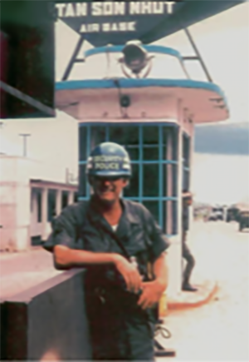
It is comforting to know that he is with his brothers Lew Goldberg, Jackie Kays and Alvin "Sarge" Matthews who very likely had this to say to Jack: "Welcome home, Jack. We've got a bunch of VSPA brothers and sisters here. This is a great place to have a reunion...we just don't have any beer. There is a tree over there where we hang our short timer ribbons. We meet at the tree to say WELCOME HOME and to remind our sisters and brothers that ain't nobody ever gonna be short again. We are all home. Now, go say hello to your Mom and Dad." - Steve Gattis
As you look at the photographs left and right, you will see and feel the sense of brotherhood Jack Smith embraced throughout the years he was a member of the VSPA.
