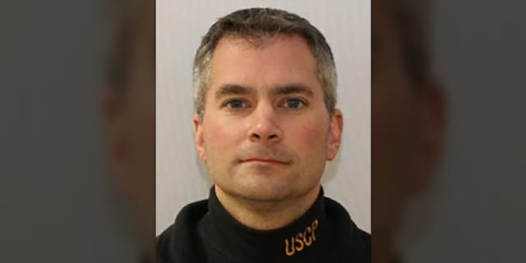
Deceased Capitol Police Brian Sicknick Lies in Honor in the U.S. Capitol, 2 February 2021, before he is buried at Arlington National Cemetery [3 February 2021]. As reported by the U.S. Capitol Police.
House Speaker Nancy Pelosi (D-Calif.) and Senate Majority Leader Charles Schumer (D-N.Y.) announced on Friday that Brian Sicknick, a Capitol Police officer who died from injuries suffered in the Jan. 6 riot, will lie in honor in the Capitol Rotunda next week.

"The U.S. Congress is united in grief, gratitude and solemn appreciation for the service and sacrifice of Officer Brian Sicknick. ... On behalf of the House of Representatives and the Senate, it is our great privilege to pay tribute to Officer Sicknick with this lying-in-honor ceremony,” Pelosi and Schumer said in a joint statement.

According to the announcement, Sicknick will lie in the Capitol Rotunda starting Tuesday night, with a viewing period starting for members of the U.S. Capitol Police starting at 10 p.m. A congressional tribute will be held Wednesday morning before Sicknick’s interment at Arlington National Cemetery.

The announcement comes amid support from lawmakers and the U.S. Capitol Police for Sicknick to receive the posthumous honor. Sicknick was hit in the head with a fire extinguisher during the riot and later died at a hospital.

"The heroism of Officer Sicknick and the Capitol Police force during the violent insurrection against our Capitol helped save lives, defend the temple of our democracy and ensure that the Congress was not diverted from our duty to the Constitution," Pelosi and Schumer said in their joint statement. "His sacrifice reminds us every day of our obligation to our country and to the people we serve."

- Lying in state is typically reserved for government officials, but Sicknick will be the fifth private citizen to lay in honor, according to the Architect of the Capitol. Jacob Joseph

Chestnut.and John Michael Gibson, two Capitol Police officers, were the first private citizens to lay in honor in 1998.
- Five people, including Sicknick, died directly because of the violence. At least two officers, one from the Capitol Police, another from D.C. Metro Police, died by suicide after responding to the riot. The Associated Press contributed to this report.
[https://www.foxnews.com/us/capitol-police-officer-brian-sicknick-lie-in-honor-rotunda-funeral-arlington-national-cemetery]

He texted me last night and said, ‘I got pepper-sprayed twice,’ and he was in good shape,” said Ken Sicknick. “Apparently he collapsed in the Capitol and they resuscitated him using CPR.” [His brother] Ken Sicknick said.

A choir from the Air Force, in which Sicknick served, sang America the Beautiful before Pelosi took the podium, heralding Sicknick's heroism and service to his country.

Schumer and Pelosi pay tribute to Capitol cop Brian Sicknick in solemn Congressional memorial | Daily Mail Online

Born:July 30, 1978, New Brunswick, New Jersey
Died:January 07, 2021, Washington, D.C.
Resting place:Arlington National Cemetery, Arlington County, Virginia

The U.S. Capitol rotunda. Massive. Humbling. Great paintings: The Surrender of General Burgoyne, another depicts the signing of the Declaration of Independence, and many others, as a statue of old Abe Lincoln looks on approvingly. Towering above the floor is the arched dome with a huge canvas painting of the “The Apotheosis” showing our first president, George Washington, god-like accompanied by thirteen maidens, all lifting to heaven itself.

A tourist guide commented the rotunda could house the Statue of Liberty (with its stand) the 180 feet to the dome, and the canvas base is the same circumference as the floor of the rotunda. I looked again at the floor, and back up to Washington; truly breath taking. I wondered what he would have thought, looking down upon the turmoil of the riotous acts below. A capitol police officer lay dead…also a woman not too far way. Screaming, shouts of rage, shouted orders by law enforcement. Not our proudest moment as a country.

Early morning hours find the rotunda void of sound, echoing the crypt located below, and truly the place where “if the tree fell… would it make a sound if no one was there”, fits.

