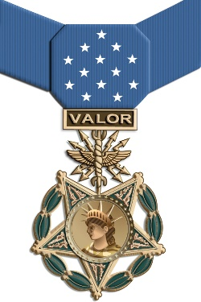
The Medal of Honor is the United States of America's
highest and most prestigious personal military decoration.

I was watching YouTube on Arlington National Cemetery and called my brother Don and asked if he knew of any foreign active duty soldiers being awarded the United States Medal of Honor. He answered that he didn’t know of any such awards. I advised that a total of five foreign soldiers have been awarded the Medal of Honor, but all were Killed in Action in WWI.
In 1921, President Harding requested the remains of four U.S. Servicemen, who were KIA in WWI, be brought to the United States. The four remains of U.S. soldiers were returned from the gravesite of a battlefield in Paris, and place in the National Rotunda. Sgt. Edward F. Younger, who served with honor in WWI, was asked to select one of the four unknown remains, who would become the first Unknown Soldier and represent all those lost by the United States in WWI. Sgt. Younger selected one of the four remains.

President Warren G. Harding awarded the “unknown soldier” the Medal of Honor and the Distinguished Service Cross. The heads of state from five allied nations attended the ceremony and presented the American WWI “unknown” their Nation’s Highest Military Award for Valor. In suit, those allied heads of state removed an unknown military member countryman, KIA in WWI, from the Paris battlefield gravesite and presented that unknown soldier its highest military award. America, under President Harding, awarded the “foreign” unknown servicemen our Medal of Honor. Hence, although no living foreign active duty soldier has ever been awarded the United States Medal of Honor, medals have been awarded to five KIA foreign allied soldiers for valor. These allied nations were France, Great Britain, Belgium, Italy & Romania.

Jerry (J.D) Poss,
President Sons American Revolution, Idaho
