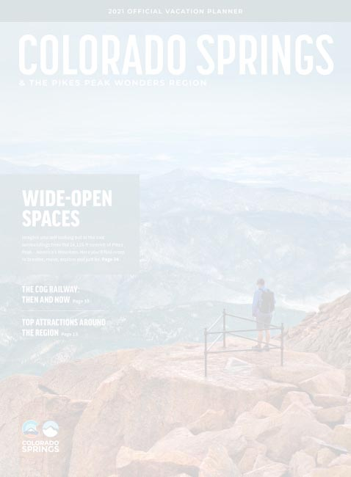
REUNION 2021
Colorado Pre Briefing Info RE - Elevation sickness precautions

From: Jerry Nelson <JrNel1423@aol.com>
Reunion 2021 Colorado Pre Briefing Info
MSgt NICHOLAS A. LEWIS, Flight Chief, DFO-B, 10th Security Forces Squadron USAF Academy emailed the below elevation sickness precautions for VSPA Reunion 2021 attendees to consider.

Questions? email: Jerry Nelson <JrNel1423@aol.com>

From: "LEWIS, NICHOLAS A MSgt USAF USAFA 10 SFS/DFO"
Date: June 16, 2021 at 10:57:33 PM CDT
Subject: Colorado Pre Briefing Info
Sir,

See below for some general info about Colorado and elevation sickness precautions. I’ve also attached links to a website with some good information.

Drink plenty of water
Bring/use chap-stick daily
Sunscreen is a must due to the elevation
Many people suffer from dry nose/nose bleeds here. This can be prevented by applying a small amount of Vaseline in each nostril with a Q-tip.

https://www.visitcos.com/travel-tools/high-altitude-tips/

https://www.visitcos.com/travel-tools/weather-how-to-pack/

V/r,

NICHOLAS A. LEWIS, MSgt, USAF
Flight Chief, DFO-B
10th Security Forces Squadron
USAF Academy CO 80840

