UNITED STATES AIR FORCE

AIR POLICE AND SECURITY POLICE KILLED IN ACTION OR LINE OF DUTY
IN THE VIETNAM WAR (Vietnam and Thailand)
Vietnam Security Police Association, Inc. (USAF): March to The Wall, 2007. Photo & Composite © 2020, Don Poss
Photo & Composite © 2020, Don Poss

A-Z, USAF AP/SP KIA-LOD ADAMS, ERHARD JIMMIE
SGT - Air Force - Regular
Age 22, Single Caucasian Male
Born 10 OCT 1948. From FAYETTEVILLE, NC
His tour of duty began on 02 SEP 1970
CAM RANH BAY AIR BASE, REPUBLIC OF VIETNAM, 12th AIR POLICE SQUADRON
Casualty was on 2 NOV 1970
in PROVINCE OF KHANH HOA, SOUTH VIETNAM
Non-Hostile [LOD]: died of ILLNESS/INJURY, GROUND CASUALTY - HEART ATTACK.
Religion – ROMAN CATHOLIC Body was recovered
Panel 06W - Line 33
*

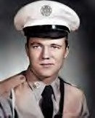
ADAMS, ROYCEHORACE
TSGT - Air Force -Regular
Age 32, Married Caucasian Male
Born 25 AUG 1936. From GRAND RIDGE, FL
Length of service 14years.
His tour of duty began on 18 MAR 1969
DA NANG AIR BASE, REPUBLIC OF VIETNAM, 366th SECURITY POLICE SQUADRON
Casualty was on 14 APR 1969
in QUANG NAM, SOUTH VIETNAM
Non-Hostile [LOD]: GROUND CASUALTY VEHICLE CRASH
Religion – METHODIST. Body was recovered Panel 27W - Line 79.
Description: Vietnam Casualty Book (Non-Hostile) reads as follows: SOUTH VIETNAM (B1): On 14 APR 1969, TSgt Royce H. Adams, AF14529460, was killed when the security police vehicle in which he was riding went out of control and rolled over after skidding on wet pavement.
*

ANDERSON, HERMAN B.
A1C- Air Force – Regular
Born 09 Jan 1946. From Florida. U-TAPAO RTAFB, THAILAND,
635th SECURITY POLICE SQUADRON
Casualty was on 08 OCT 1971 Non-Hostile: GROUND CASUALTY Body was recovered.
Description: Vehicle vs. Pedestrian.
*

ANTHONY, PAUL WAYNE
A1C- Air Force – Regular.
Age 20, Married Male Caucasian.
Born May 27, 1949 - From CHARLOTTE, NC
Length of service 1 years - His tour began on Apr 3, 1970,DA NANG AIR BASE, REPUBLIC OF VIETNAM,
366th SECURITY POLICE SQUADRON; 6498th SECURITY POLICE SQUADRON.
Tour began Apr 3, 1970.
Casualty was on Apr 8, 1970, In QUANG NAM, SOUTH VIETNAM
HOSTILE [KIA]: GROUND CASUALTY ARTILLERY, ROCKET, or MORTAR
[KIA 5th day at Da Nang Air Base, RVN] Religion – PRESBYTERIAN
Body was recovered Panel 12W - Line 105.
*

BESTMANN, CHARLES EDWARD
SGT - Air Force – Regular
Age 22, Single Male Negro, Male
Born 01 SEP 1946. From FLUSHING, NY
Length of service 2 years.
His tour of duty began on 30 AUG 1968
PHAN RANG AIR BASE (TDY), REPUBLIC OF VIETNAM, 821st SECURITY POLICE SQUADRON
Casualty was on 28 NOV 1968 in GIA DINH, SOUTHVIETNAM
Non-Hostile [LOD]: died of ILLNESS/INJURY, GROUND CASUALTY VEHICLE CRASH Religion - EPISCOPAL, ANGLICAN
Body was recovered Panel 38W - Line 82.
*

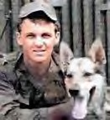
BEVICH, GEORGE MICHAEL, JR.
A2C Air Force – Regular. Age 22, Single Caucasian Male Born 10 JUL 1944 - From SUMMIT HILL, PA.
Length of service 3 years.
His tour of duty began on 13 APR 1966
TAN SON NHUT AIR BASE, REPUBLIC OF VIETNAM, 377th POLICE SQUADRON
Casualty was on 04 DEC 1966 in GIA DINH, SOUTH VIETNAM.
HOSTILE, GROUND CASUALTY ARTILLERY, ROCKET, or MORTAR
Body was recovered. Panel 13E - Line 9.

Description: The Vietnam Casualty Book (Non-Hostile) reads: A2C George Bevich, Jr. was the first Air Force Dog Handler to die in Vietnam. He was stationed at TAN SON NHUT AIR BASE AIR BASE, REPUBLIC OF VIETNAM, 377th SECURITY POLICE
SQUADRON, and was killed in action on the night of DEC 6, 1966.
*

BIRKET, SCOTT LEE
A1C - Air Force – Regular
Age 21, Single Caucasian Male
Born 22 NOV 1950. From LAMIRADA, CA
Casualty was on 20 SEP 1972
DA NANG AIR BASE, REPUBLIC OF VIETNAM, 6498th SECURITY POLICE SQUADRON in QUANG NAM, SOUTH VIETNAM
Non-Hostile [LOD]: GROUND CASUALTY – SUICIDE Religion - LUTHERAN & MISSOURI SYNOD
Body was recovered. Panel 01W -Line 76.
*

BLACK, JIMMY P.
SGT - Air Force Age 20, Male.
Born 24 AUG 1954 From DAPHNE, AL. NAKHON PHANOM RTAFB, THAILAND, 56th SECURITY POLICE SQUADRON
Casualty was on 13 MAY 1975
Non-Hostile, Helicopter Crash (Eighteen 56th SPS were Killed) (Mayaguez Rescue Operation Cambodia, 12- 15 MAY 1975).
Body was recovered Panel 01W - Line 124.

BLAKENEY, MELVIN JASON
SGT - Air Force Born 22 OCT 1949 From: Pageland, SC
NAKHON PHANOM RTAFB, THAILAND, 56th SECURITY POLICE SQUADRON
Casualty was on 07 JUL 1973
Non-Hostile [LOD]: ILLNESS/Disease. Body was recovered.
*

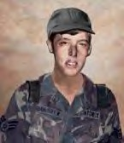
BOLSTER, DAN ARTHUR
A1C - E3 - Air Force – Regular 21years old Single Caucasian Male
Born 2 AUG 1950. From SEATTLE, WA.
His tour of duty began on 19 MAR 1971
DA NANG AIR BASE, REPUBLIC OF VIETNAM, 366th SECURITY POLICE SQUADRON
Casualty was on 07 JAN 1972 in QUANG NAM, SOUTHVIETNAM Non-Hostile [LOD]: died of ILLNESS/INJURY GROUND CASUALTY, ACCIDENTAL - SELF-DESTRUCTION
Religion- EPISCOPAL, ANGLICAN
Body was recovered Panel 02W - Line 95
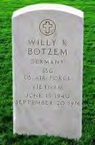
*

BOTZEM, WILLY KUEPPER
SSGT - Air Force – Regular Born 13 JUN 1940
UBON RTAFB, THAILAND, 8th SECURITY POLICE SQUADRON
Casualty was on 20 SEP 1971 Non-Hostile GROUND CASUALTY. Body was recovered.
Description: Jeep vs. Pedestrian.
*

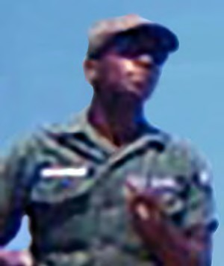
BOYD, JAMES
SGT Air Force –Regular
Age 22, Married, Negro, Male
Born 24 JUN 1945. From WINSTON-SALEM, NC
Length of service 4 years.
His tour of duty began on 04 FEB 1968
BIEN HOA AIR BASE, REPUBLIC OF VIETNAM, 3d AIR POLICE SQUADRON
Casualty was on 28 FEB 1968 in BIEN HOA, SOUTH VIETNAM,
HOSTILE [KIA], , GROUND CASUALTY ARTILLERY, ROCKET, or MORTAR
Religion –BAPTIST. Body was recovered. Panel 41E - Line 59.
*

BRIDGES, ROBERT EARL
A2C - Air Force – Regular
Age 20, Single, Caucasian, Male Born 31 JAN 1945 in GRANBY, CT.
Length of service 2 years.
His tour of duty began on 28 NOV 1966
BIEN HOA AIR BASE, REPUBLIC OF VIETNAM, 3d AIR POLICE SQUADRON
Casualty was on 17 JUN 1967 in BIEN HOA, SOUTH VIETNAM. Non-HOSTILE [LOD], GROUND CASUALTY OTHER CAUSES
Body was recovered. Panel 21E - Line 117

Description: Struck by Lightning/Guard Tower post.
*

BRYANT, CHARLES E.
SSgt - Air Force
DON MUANG RTAFB, THAILAND, 631st SECURITY POLICE SQUADRON
Casualty was on 11 APR 1968
Non-Hostile [LOD]: Drowned/Chao Phya River. Body was recovered.
*

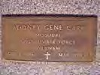
CARR, RODNEY GENE
SSgt - Air Force 22-Year-oldMale
Born 1 SEP 1941 - from FL.
TAN SON NHUT AIR BASE, REPUBLIC OF VIETNAM, 377th POLICE SQUADRON DOD: 10 MAR 1973 at SAIGON, 804th (Hospital)
Non-Hostile Casualty was on 10 MAR 1973 Non-Hostile: Vehicle Crash
*

CLOSSON, JAMES STANLEY
A1C - Air Force – Regular
Age 21, Single Caucasian Male
Born SEP 21, 1947. From SARATOGA SPRINGS, NY
Length of service 1 year
His tour of duty began on JUL 13, 1968
DA NANG AIR BASE, REPUBLIC OF VIETNAM, 366th SECURITY POLICE SQUADRON
Casualty was on JAN 12, 1969, In QUANG NAM, SOUTH VIETNAM Non-HOSTILE [KIA], , GROUND CASUALTY DROWNED, SUFFOCATED.
Body was recovered. Panel 35W - Line 75.
Description: Died of accidental drowning at a recreational area with friends.
*

COLE, JOHNMATTHEW
A2C Air Force – Regular
Age 20, Single Caucasian Male
Born 18 JUN 1946. From PHILADELPHIA, PA
Length of service 2 years.
His tour of duty began on 20 JUL 1966
TAN SON NHUT AIR BASE, REPUBLIC OF VIETNAM, 377th SECURITY POLICES SQUADRON
Casualty was on 04 DEC 1966 in GIA DINH, SOUTH VIETNAM
HOSTILE, GROUND CASUALTY ARTILLERY, ROCKET, or MORTAR
Body was recovered Panel 13E - Line 11
*

COLLUMS, BOBBY GLEN
SGT - Air Force Age 22, Male
Born 24 SEP 1952
From HELENA, DESCRIPTION
NAKHON PHANOM RTAFB, THAILAND, 56th SECURITY POLICE SQUADRON
Casualty was on 13 MAY 1975
Non-Hostile [LOD]: Helicopter Crash (Eighteen 56th SPS were Killed) (Mayaguez Rescue Operation, Cambodia,12-15 MAY 1975).
Body was recovered Panel 01W –Line 125.
*

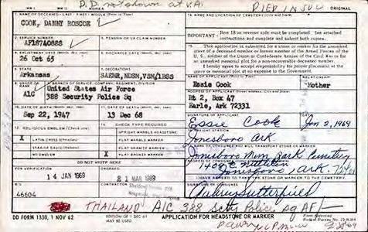
COOK, DANNY ROSCOE
A1C - Air Force Born 27 SEP 1947
KORAT RTAFB, THAILAND, 388th SECURITY POLICE SQUADRON
Casualty was on: 13 DEC 1968
Non-Hostile [LOD]: Truck vs. motorcycle. Body was recovered.
*

CORDON, HUBERT C.
A1C – Air Force
30 JUN 1973 Non-Hostile
KORAT RTAFB, THAILAND, 388th SECURITY POLICE SQUADRON
Non-Hostile [LOD]: Accidental Self-Destruction (Gunshot).

Description: Airman was an entry controller at a munitions marshaling area adjacent to the KORAT RTAFB, THAILAND flight Line; died from a self- inflicted gunshot during chow relief, witnessed by several other SP personnel.

*

COYLE, GERALD A.
SSGT - Air Force Age 31, Male Born 14 MAY 1943 From BENTLEYVILLE, PA
NAKHON PHANOM RTAFB, THAILAND, 56th SECURITY POLICE SQUADRON
Casualty was on 13 MAY 1975.
Non-Hostile [LOD]: Helicopter Crash - During the SS Mayaguez Rescue Operation, Cambodia, 12-15 MAY 1975.
Body was recovered. Panel 01W -Line 125.
*

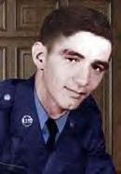
CYR, WILLIAM JOSEPH (Silver Star, posthumously) SGT - E4 - Air Force – Regular
Age 22, single Male
Born 22 OCT 1945. From WEBSTER, MA
Length of service 2 years
His tour began on Nov 16,1967
TAN SON NHUT AIR BASE, REPUBLIC OF VIETNAM, 377th POLICE SQUADRON
Casualty was on Jan 31, 1968, In GIA DINH, SOUTH VIETNAM
HOSTILE, GROUND CASUALTY ARTILLERY, ROCKET, or MORTAR.
Religion – Catholic.
Body was recovered. Panel 36E - Line 5

Description: On the night of 31 January 1968, Sgt. Cyr was one of five men who manned the O-51 Bunker at Tan Son Nhut Air Base during the attack by NVA forces. They were directly attacked by Bangalore type charges and RPG rockets. The bunker was overwhelmed by enemy forces.

[Casualties killed in action during the Attack on the Air Base: 22 U.S.; 29 RVN; 669 NVA and Viet Cong; 26 NVA/VC POW.
*

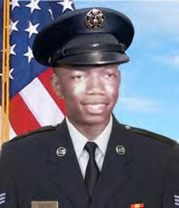
DAVIS, AARON, JR.
Age 21, Caucasian Male
Born on 04 OCT 1949. From ROCHESTER, NY
His tour began on 16 May 1970
PHU CAT AIR BASE, REPUBLIC OF VIETNAM, 12th SECURITY POLICE SQUADRON
Casualty was on 12 FEB 1971, in BINH DINH PROVINCE, SOUTH VIETNAM,
HOSTILE, GROUND CASUALTY OTHER EXPLOSIVE DEVICE.
Body was recovered. Panel 05W – Line 98
*

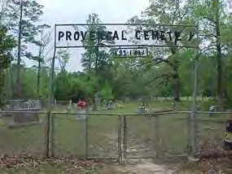
DAVIS, JOHN B.
CMSGT - Air Force
Casualty was on 14 JUN 1973
NAKHON PHANOM RTAFB, THAILAND, 56th SECURITY POLICE SQUADRON
Non-Hostile [LOD]: Heart Attack. Body was recovered.
*

DEWOLF, DALE LEE
SGT - Air Force – Regular
Age 20, Single Caucasian Male Born 06 JUL 1952
From NEBRASKA CITY, NE
His tour of duty began on 29 MAR 1972
TAN SON NHUT AIR BASE, REPUBLIC OF VIETNAM, 377th SECURITY POLICE
SQUADRON Casualty was on 02 MAY 1973 in GIA DINH, SOUTH VIETNAM
Non-Hostile [LOD]: died of Illness/INJURY GROUND, CASUALTY-VEHICLE LOSS CRASH. Religion– PROTESTANT – NON-DENOMINATIONAL
Body was recovered. Panel 01W - Line 115.

Description: Killed when his jeep rolled over on him.
*

DEUSTER, WILLIAM J., JR.
SGT - Air Force – Regular
UDORN RTAFB, THAILAND, 825 CDS
Casualty was on 27 APR 1967
Non-Hostile Crushed between Vehicles (Gate Duty)
*

DWYER, THOMAS D.
SGT – Air Force Age 21, Male
Born JUN 17, 1953. From MIDDLEBURY, CT
NAKHON PHANOM RTAFB, THAILAND, 56th SECURITY POLICE SQUADRON Casualty
was on 13 MAY 1975
Non-Hostile [LOD]: Helicopter Crash
(Eighteen 56th SPS were Killed) (Mayaguez Rescue Operation, Cambodia 12-15 MAY 1975).
Body was recovered. Panel 01W- Line 125
*

ENGLAND, JAMES C.
Sgt - Air Force
U-TAPAO RTAFB, THAILAND, 635th SECURITY POLICE SQUADRON
Casualty was on 01 MAR 1970 Non-Hostile: Gunshot.
Body was recovered.
*

EVANS, JOHN HARPER, JR.
Airman - Air Force – Regular Age 20, Single, Negro, Male
Born 01 APR 1950. From HEMPSTEAD, NY
PHAN RANG AIR BASE, REPUBLIC OF VIETNAM, 35th SECURITY POLICE
SQUADRON His tour of duty began on 18 APR 1970
Casualty was on 07 AUG 1970 in KHANH HOA, SOUTH VIETNAM, Non-Hostile [LOD]: GROUND CASUALTY -
ACCIDENTAL SELF-DESTRUCTION Religion - ROMAN CATHOLIC.P
Body was recovered. Panel 08W - Line 90
*

FAIRCLOTH, LARRY R.
SSgt - Air Force
Length of service Vietnam: 1967-1968
MUKDAHAN, VIKING STATION RADAR, THAILAND, DET-6, 621st TAC SQ.
Casualty was on 05 APR 1968 in GIA DINH, SOUTH VIETNAM
Non-Hostile: ILLNESS/Disease – Aneurysm (Possible Hospital Evacuate) Body was recovered.
[No Photo. Drawing from SSgt Faircloth’s obit article]

*

FIELDS, ROBERT LOUIS, III
A2C - Air Force – Regular
Age 21, Single Caucasian Male
Born 01 FEB 1944. From GALESBURG, IL
Length of service 2 years.
CAM RANH BAY AIR BASE, REPUBLIC OF VIETNAM, 12th AIR POLICE SQUADRON
Casualty was on 27 JAN 1966, in KHANH HOA, SOUTH VIETNAM
Non-Hostile died missing - GROUND CASUALTY - DROWNED, SUFFOCATED Body was recovered.
Panel 04E - Line 99
*

FISCHER, LOUIS HAROLD
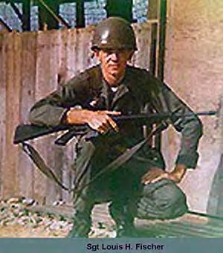
SGT - E4 - Air Force – Regular Age 22, Single Caucasian Male Born 19 DEC 1945
From WOOD HAVEN, NY
Length of service 2 years
TAN SON NHUT AIR BASE, REPUBLIC OF VIETNAM, 7th AF HQ/MACV
His tour began on Apr 15, 1967
Casualty was on Jan 31, 1968, In GIA DINH, SOUTH VIETNAM.
HOSTILE, GROUND CASUALTY, ARTILLERY, ROCKET, or MORTAR
Religion – Roman Catholic
Body was recovered - Panel 36E - Line 8
*

FORD, BERNARD FRANCIS
A1C - Air Force – Regular
Age 33, Single Caucasian Male Born 09 JAN 1934
From OAK LAWN, IL
Length of service 14 years.
PHAN RANG AIR BASE, REPUBLIC OF VIETNAM, 35th AIR POLICE SQUADRON
Casualty was on 05 JUL 1967
in NINH THUAN, SOUTH VIETNAM
Non-Hostile [LOD]: GROUND CASUALTY - ACCIDENTAL HOMICIDE
Body was recovered - Panel 23E - Line 10
*

FORD, BOB WAYNE
SGT - Air Force Age 21, Male
Born 19 FEB 1954 From SEMINOLE, TX
NAKHON PHANOM RTAFB, THAILAND, 56th SECURITY POLICE SQUADRON Casualty
was on 13 MAY 1975
Non-Hostile [LOD]: Helicopter Crash (Eighteen 56th SPS were Killed) (Mayaguez Rescue Operation, Cambodia, 12-15 MAY 1975) Body was recovered - Panel 01W Line 125

Steve Davidson - Comment: I have a better understanding of how things are now, but I don't agree with the "Washington D.C. bean counters" [not issuing Purple Hearts to Mayaguez SPs], but that's not unusual. Sgt Bob Wayne Ford was a good friend of mine. We were stationed together at Kingslely Field, OR, from 72-75.He left for Thailand in early 1975 and I was attending Camp Bullis en route to Korea when we first learned of his (and the others who were killed) death in the helicopter crash. You have a great web site and I'm glad to see that all Security Police who served in Vietnam are honored and remembered with integrity. Thanks! Steve Davidson.
*

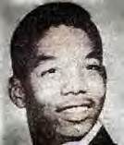
FOSTER, TONY CURTIS
A1C - Air Force – Regular Age 21, Single, Negro, Male Born 02 MAR 1948
From PHILADELPHIA, PA
Length of service 2 years.
PHU CAT AIR BASE, REPUBLIC OF VIETNAM, 821st COMBAT SECURITY POLICE, SAFESIDE
Casualty was on 05 DEC 1969 in BINH DINH, SOUTH VIETNAM
Non-Hostile [LOD]: GROUND CASUALTY OTHER ACCIDENT: EXPLOSIVE DEVISE Religion - EPISCOPAL, ANGLICAN
Body was recovered - Panel 15W - Line 27
Description: Died of multiple fragment wounds of the body when he stepped on an explosive device while performing duty as a security policeman on the northwest corner of Phu Cat Air Base.
*

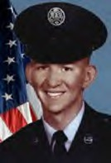
FRANCIS, JAMES EDWARD (Airman's Medal)
A1C - Air Force – Regular
Age 21, Married Caucasian Male Born 16 JUN 1946
From ST. Louis, MO. Length of service 2 years.
His tour began on 16 OCT 1967 In, Thailand
KORAT RTAFB, THAILAND 388th SECURITY POLICE SQUADRON
Casualty was on 11 MAR 1968
Non-Hostile [LOD]: died of Illness/Injury, GROUND CASUALTY OTHER EXPLOSIVE DEVICE. Bomb Dump Explosion (and rescue).
Religion – BAPTIST.
Body was recovered - Panel 44E - Line 14
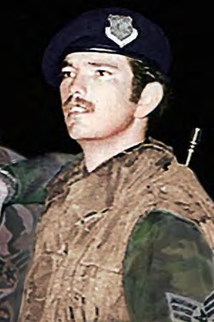
*

FRITZ, GERALD W.
SGT - Air Force Age 21, Male Born MAY 6, 1954
From JUNCTION, TX
NAKHON PHANOM RTAFB, THAILAND, 56th SECURITY POLICE SQUADRON
Casualty was on 13 MAY 1975
Non-Hostile [LOD]: Helicopter Crash (18 SPs of the 56th SPS were Killed), in route to the Mayaguez Rescue Operation, Cambodia, on 12-15 MAY 1975.
Body was recovered. Panel 01W –Line 125.
*

FULLER, GARY LEROY
A2C - Air Force – Regular
Age 21, Married, Caucasian, Male
Born OCT 18, 1945. From THE PLAINS, OH
Length of service 2 years.
His tour of duty began on 26 DEC 1966
DA NANG AIR BASE, REPUBLIC OF VIETNAM, 366th SECURITY POLICE SQUADRON.
Casualty was on 27 FEB 1967 in QUANG NAM, SOUTH VIETNAM.
HOSTILE, GROUND CASUALTY - ARTILLERY, ROCKET, or MORTAR.
Body was recovered. Panel 15E - Line 105.
*

GABRIEL, CHARLES DAVID
A2C - Air Force – Regular Age 20, Single, Negro, Male
Born 01 DEC 1946. From PALMER, TX
Length of service 1 year. His tour of duty began on 26 OCT 1966 TAN SON NHUT AIR BASE REPUBLIC OF VIETNAM,
377th SECURITY POLICE SQUADRON
Casualty was on 06 JAN 1967, in GIA DINH, SOUTH VIETNAM, Non-Hostile [LOD]: GROUND CASUALTY - ACCIDENTAL HOMICIDE
Body was recovered - Panel 13E - Line 118
*

GALLOWAY, MELVIN R.
Airman - Air Force Born APR 22, 1947. From: BREVARD, NC
KORAT RTAFB, THAILAND
388th SECURITY POLICE SQUADRON
Casualty was on 06 MAR 1970 Non-Hostile [LOD]: Suicide Body was recovered.
*

GAY, GARY PAUL
A1C - Air Force - Regular
Age 24, Married Caucasian Male
Born NOV 21, 1941. From CONEMAUGH, PA
Length of service 6 years.
His tour of duty began on 22 JAN 1966
CAM RANH BAY AIR BASE, REPUBLIC OF VIETNAM, 12th AIR POLICE SQUADRON
Casualty was on 27 JAN 1966, in KHANH HOA, SOUTH VIETNAM Non-Hostile [LOD]: GROUND CASUALTY - DROWNED, SUFFOCATED
Body was recovered - Panel 04E - Line 99
*

GLENN, JACKIE D.
TSGT - Air Force Age 36, Male
Born 10 MAY 1939 From SEYMOUR, MO
Casualty was on 13 MAY 1975 NAKHON PHANOM RTAFB, THAILAND,
56th SECURITY POLICE SQUADRON Casualty was on 13 MAY 1975
Non-Hostile [LOD]: Helicopter Crash (Eighteen 56th SPS were Killed) (Mayaguez Rescue Operation, Cambodia, 12-15 MAY 1975)
Body was recovered Panel 01W – Line 126
*

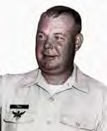
GRAY, GEORGE CHRISTIAN
SMSgt - Air Force - Regular
Age 43, Married Caucasian Male. Born FEB 06, 1926
From GRINDSTONE, PA
Length of service 20 years.
His tour of duty began on 31 JAN 1969
QUI NHON AIR BASE, REPUBLIC OF VIETNAM, 37th SECURITY POLICE SQUADRON
Casualty was on 29 MAR 1969 in BINH DINH, SOUTH VIETNAM
Non-Hostile died of ILLNESS/INJURY GROUND – CASUALTY HEART ATTACK.
Religion – BAPTIST. Body was recovered. Panel 28W - Line 81.
*

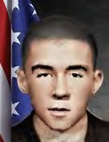
GRENIER, JOSEPH KENT
A1C - Air Force - Regular
Age 23, Single Caucasian Male. Born OCT 30, 1946
From ST. JOSEPH, MO
His tour of duty began on MAY 18, 1970
NHA TRANG AIR BASE, REPUBLIC OF VIETNAM, 327th CSG
Casualty was on SEP 04, 1970, at
NT, 327th CSG, 1st Flight (Surgical) DET): (LOD) in KHANH HOA PROVIENCE, SOUTH VIETNAM
Non-Hostile [LOD]: GROUND CASUALTY - ACCIDENTAL SELF-DESTRUCTION
Body was recovered. Panel 07W - Line 37

Description: Accidental Self-Destruction: Gunshot.
*

GRILLO, LAWRENCE HUGH
A1C - Air Force – Regular
Age 21, Single Caucasian Male.
Born DEC 15, 1947. From BRIDGEPORT, CT
Length of service 1 year.
His tour of duty began on 11 APR 1969
PHAN RANG AIR BASE, REPUBLIC OF VIETNAM, 35th SECURITY POLICE SQUADRON Casualty was on 28 MAY 1969, in NINH THUAN, SOUTH VIETNAM
Non-Hostile [LOD]: GROUND CASUALTY - OTHER CAUSES
Religion - ROMAN CATHOLIC.
Body was recovered - Panel 23W - Line 8.
Description: Struck by lightning/Guard Tower.
*

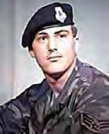
HAMLIN, DARRELL L.
SGT – Air Force Age 19, Male
Born 20 OCT 1955. From IOWA CITY, IA NAKHON PHANOM RTAFB, THA
LAND, 56th SECURITY POLICE SQUADRON Casualty was on 13 MAY 1975
Non-Hostile, Helicopter Crash
(Eighteen 56th SPS were Killed) (Mayaguez Rescue Operation, Cambodia, 12-15 MAY 1975)
Body was recovered - Panel 01W - Line 126
*

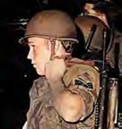
HANKAMER, GREGORY L.
SGT - E4 - Air Force
Age 21, Caucasian Male
Born 15 SEP 1953. From SAN PEDRO, CA
NAKHON PHANOM RTAFB, THAILAND, 56th SECURITY POLICE SQUADRON
Casualty was on 13 MAY 1975, In, THAILAND
Non-Hostile [LOD]: Helicopter Crash (Eighteen 56th SPS were Killed) (Mayaguez Rescue Operation, Cambodia, 12-15 MAY 1975)
Body was recovered - Panel 01W - Line 126
*

HARDEN, ROOSEVELT JR.
A3C – Air Force
Age 20, Male - Born 18 MAR 1945
NAKHON PHANOM RTAFB, THAILAND, 56th AIR POLICE SQUADRON Casualty was on 11 JUL 1967.
Non- Hostile. Gunshot/Guard duty. Body was recovered.
*

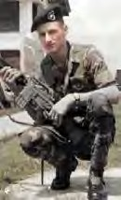
HEBRON, CHARLES EDWARD
SGT - E4 - Air Force – Regular Age 22, Married Male
Born 18 SEP 1945. From: BRYAN, TX
Length of service 3 years
His tour began on Mar 21, 1967
TAN SON NHUT AIR BASE, REPUBLIC OF VIETNAM, 377th SECURITY POLICE SQUADRON
Casualty was on Jan 31, 1968, In GIA DINH, SOUTH VIETNAM
HOSTILE, GROUND CASUALTY ARTILLERY, ROCKET, or MORTAR
Religion – ROMAN CATHOLIC Body was recovered.
Panel 3 6E - Line 13
*

HICKS, JAMES RUSSELL
SSGT - Air Force – Regular
Age 21, Single Caucasian Male Born 29 SEP 1949,
From STILLWATER, MN
Tour of duty began on 09 DEC,1970
DA NANG AIR BASE, REPUBLIC OF VIETNAM, 366th SECURITY POLICE SQUADRON
Casualty was on 06 MAR 1971,
in QUANG NAM, SOUTH VIETNAM
Non-Hostile [LOD]: GROUND CASUALTY - ACCIDENTAL HOMICIDE. Religion - EVANGELICAL COVENANT.
Body was recovered. Panel 04W - Line 27.

Description: Sgt James Russell Hicks (SSgt, Promoted Posthumously) Died of a gunshot wound to the head.
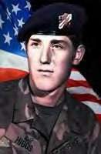
*

HIGGS, DAVID ALAN
SGT – Air Force Age 20, Male
Born 05 MAY 1955 From SPOKANE, WA
NAKHON PHANOM RTAFB, THAILAND, 56th SECURITY POLICE SQUADRON
Casualty was on 13 MAY 1975
Non-Hostile [LOD]: Helicopter Crash (Eighteen 56th SPS were Killed) (Mayaguez Rescue Operation, Cambodia,12-15 MAY 1975).
Body was recovered. Panel 01W -Line 126.
*

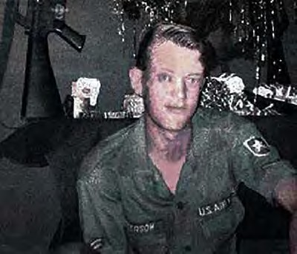
HOLBROOK, HORACE ALVIE
A2C - E3 - Air Force – Regular Age 21, Single, Caucasian, Male Born 4 OCT 1945
From JACKSONVILLE, AL
Length of service 2 years
His tour began on Nov 16, 1966
BIEN HOA AIR BASE, REPUBLIC OF VIETNAM, 3d AIR POLICE SQUADRON
Casualty was on May 12, 1967, in BIEN HOA, SOUTH VIETNAM
HOSTILE, GROUND CASUALTY ARTILLERY, ROCKET, or MORTAR
Body was recovered Panel 19E - Lin 96
Description: Photo of Holbrook's last Christmas before KIA.
*

HOLLEY, GLYNN BYRON
A1C - Air Force – Regular
Age 20, Single, Caucasian, Male Born 27 MAY 1949.
From MIDLAND, TX
Length of service 1 year.
His tour of duty began on 06 DEC 1969
CAM RANH BAY AIR BASE, REPUBLIC OF VIETNAM, 12th AIR POLICE
SQUADRON Casualty was on 26 DEC 1969 in KHANH HOA, SOUTH VIETNAM
Non-Hostile [LOD]: died of ILLNESS/INJURY GROUND CASUALTY ILLNESS, DISEASE Religion - CHURCH OF CHRIST
Body was recovered Panel 15W - Line 93
*

ILAOA, FALEAGAFULA
SSGT - Air Force Age 27, Male
Born 06 APR 1948. From SAN FRANCISCO, CA NAKHON PHANOM RTAFB, THAILAND,
56th SECURITY POLICE SQUADRON
Casualty was on 13 MAY 1975
Non-Hostile [LOD]: Helicopter Crash (Eighteen 56th SPS were Killed) (Mayaguez Rescue Operation, Cambodia, 12-15 MAY 1975)
Body was recovered Panel 01W -Line 127
*

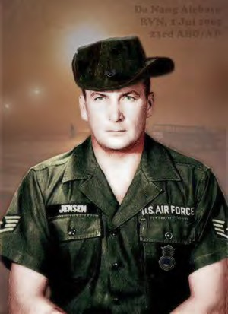
JENSEN, TERANCE KAY
[First Air Policeman KIA in Vietnam War] SSGT - Air Force - Regular
Age 33, Married Caucasian Male Born 14 JAN 1932
From DETROIT LAKES, MN
Length of service 14 years.
DA NANG AIR BASE, REPUBLIC OF VIETNAM, 23rd AIR BASE GROUP/ AIR POLICE
Casualty was on 01 JAN 1965 [First of 112 AP/SP KIA/LOD] in QUANG NAM (DA NANG AIR BASE), SOUTH VIETNAM
HOSTILE, GROUND CASUALTY OTHER EXPLOSIVE DEVICE (NVA Gun Shot)
Body was recovered Panel 02E - Line 26

Description: Patricia Jensen (daughter) Subject: Re: SSgt Jensen, DA NANG AIR BASE, REPUBLIC OF VIETNAM, JUL 1, 1965 – My dad is buried at Oak Grove Cemetery in Detroit Lakes MN. The plot is S21. He is in the area where there are no headstones. He has a Silver Star on a stake that says veteran on it.
When you are facing the cemetery at the main gate he is to the left, the section is to the farthest side, towards the front. Please let me know if there are any grave sites here in southern Oregon that I could visit. I will try to scan the photo and send it to you; I will need my son to help. Happy Holidays, Patricia Jensen. [SSgt Jensen had two daughters who would enlist in the Air Force as Security Police.]
*

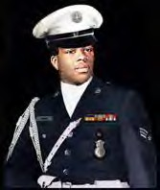
JONES, BRUCE DALE
SGT (Posthumous Promotion)- Air Force– Regular Age 20, Single, Negro, Male
Born JAN 14, 1952
From Evergreen, AL
His tour of duty began on 15 JAN 1972
TAN SON NHUT AIR BASE, REPUBLIC OF VIETNAM, 377th SECURITY POLICE SQUADRON
Casualty was on 9 MAR 1972 in GIA DINH, SOUTH VIETNAM Non-Hostile [LOD]: died of ILLNESS/INJURY,
Accidental Self-Destruction. Body was recovered.
Panel 02W- Line 114
*

JONES, JAMES BRUCE
[2nd Air Policeman KIA in the Vietnam War] A3C - Air Force -Regular
Age 20, Single, Caucasian Male
Born 15 DEC 1945. From ALEXANDRIA BAY, NY
Length of service 1 year.
DA NANG AIR BASE, REPUBLIC OF VIETNAM, 6252nd AIR POLICE SQUADRON Casualty was on 25 JAN 1966 in QUANG NAM (DA NANG AIR BASE), SOUTH VIETNAM HOSTILE, GROUND CASUALTY - OTHER EXPLOSIVE DEVICE, MORTARS
Body was Recovered Panel 04E - Line 093
*

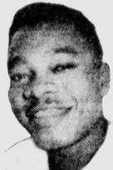
KELSEY, J C
A1C - Air Force - Regular
Age 30, Married, Negro, Male Born 22 MAR 1936
From DETROIT, MI
NHA TRANG AIR BASE, REPUBLIC OF VIETNAM, 14th AIR POLICE SQUADRON Length
of service 12 years.
Casualty was on 02 DEC 1966
in KHANH HOA, SOUTH VIETNAM
Non-Hostile [LOD]: died of ILLNESS/INJURY GROUND CASUALTY VEHICLE CRASH
Body was recovered Panel 13E - Line 6
*

KEMP, JIMMY
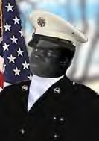
A2C - Air Force – Regular Age 19, Single, Negro, Male
Born 08 JUL 1947. From CLEMSON, SC
Length of service 1 year.
PHU CAT AIR BASE, REPUBLIC OF VIETNAM, 37th AIR POLICE SQUADRON
His tour of duty began on 29 MAR 1967 Casualty was on 06 JUN 1967
in BINH DINH, SOUTH VIETNAM
Non-Hostile [LOD]: GROUND CASUALTY - DROWNED, SUFFOCATED
Body was recovered Panel 21E - Line 62

Description: While swimming Jimmy Kemp’s body suddenly sank below the surface. As the M60 Gunner, the weight of his equipment and the swift current of the river, he was unable to surface. His remains were subsequently recovered.
*

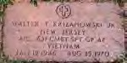
KRIZANOWSKI, WALTER T., JR.
A1C - Air Force, Age 24 Born 19 JAN 1946
DON MUANG RTAFB, THAILAND, 631st SECURITY POLICE SQUADRON/CSG
Casualty was on 25 AUG 1970
Non-Hostile [LOD]: Train vs. Vehicle. Body was recovered.
Burial: Rosedale and Rosehill Cemetery, Lined, New Jersey

BANGKOK, Thailand, Aug. 26 (Reuters) — An express train traveling at full speed struck bus, killing seven American Airmen and injuring four others at a railroad crossing near Bangkok's Don Muang airport, police sources said today. The bus was taking the Airmen to their headquarters from the airport fifteen miles north of Bangkok last night when the collision occurred at an unguarded crossing, the police said. The police identified the dead Airmen as Thomas J. Broad water, Age 26, Handel Emila Jr., 26; Paul C. Saver, 22; Richard H. Stanton; 40; Walter Krizanowski, 24; Richard Gregsby, 21, and Paul Edmundson, 22.
*

LANE, MICHAEL DAVID
SGT - Air Force Age 25, Male Born 04 JAN 1950.
From JACKSONVILLE, FL.
NAKHON PHANOM RTAFB, THAILAND, 56th SECURITY POLICE SQUADRON
Casualty was on 13 MAY 1975
Non-Hostile [LOD]: Helicopter Crash - During the SS Mayaguez Rescue Operation, Cambodia, 12-15 MAY 1975.
Body was recovered Panel 01W - Line 127
*

LEHMAN, MILLARD WESLEY
A1C - E4 - Air Force – Regular Age 23, Single Caucasian Male
Born 14 MAY 1943. From NACO, DESCRIPTION
BINH TUY AIR BASE, REPUBLIC OF VIETNAM, 632nd AIR POLICE SQUADRON
Length of service 4 years
Casualty was on 06 Jul 1966 In PHONG DINH, SOUTH VIETNAM
HOSTILE, GROUND CASUALTY ARTILLERY, ROCKET, or MORTAR
Body was recovered Panel 09E - Line 7
*

LOFTIS, JOEL CONRAD
A1C - Air Force – Regular Age 22, Single, Negro, Male Born JUN 17, 1946
From LA MANQUÉ, TX
Length of service 1 years.
His tour began on 7 Dec 1968.
PHAN RANG AIR BASE, REPUBLIC OF VIETNAM, 35th SECURITY POLICE SQUADRON
Casualty was on 07 JUN 1969
in NINH THUAN, SOUTH VIETNAM
HOSTILE, GROUND CASUALTY ARTILLERY, ROCKET, or MORTAR
Religion – ROMAN CATHOLIC Body was recovered.
Panel 23W - Line 104
Description: Hostile Rocket attack.
*

LONDON, DENNIS WAYNE
SGT - Air Force Age 25, Male Born 21 AUG 1949
From SPARKS, NC
NAKHON PHANOM RTAFB, THAILAND, 56th SECURITY POLICE SQUADRON
Casualty was on 13 MAY 1975
Non-Hostile [LOD]: Helicopter Crash - During the SS Mayaguez Rescue Operation, Cambodia, 12-15 MAY 1975.
Body was recovered Panel 01W - Line 127.
*

MALONE, BOBBY J.
Sgt - Air Force Born 3 APR 1944
From Slaton, Texas
UBON RTAFB, THAILAND, 8th SECURITY POLICE SQUADRON
Casualty was on 3 FEB 1968 Non-Hostile [LOD]: Drowned. Body was recovered.
*

MAC ARTHUR, DALE ALAN
Age 22, Single Caucasian Male Born 16 JAN 1947
From SUNNYSIDE, WA
PHU CAT AIR BASE, REPUBLIC OF VIETNAM, 821st COMBAT SECURITY POLICE, SAFESIDE
His tour of duty began on SEP 01, 1969,Casualty was on DEC 08, 1969, in NINH THUAN, SOUTH VIETNAM.
Non-Hostile [LOD]: died of ILLNESS/INJURY, GROUND
CASUALTY VEHICLE ACCIDENT - Thrown from jeep. Religion - DISCIPLES OF CHRIST
Body was recovered. Panel 15W - Line 39.
*

MATELSKI, LEONARD JAMES
SSGT – E5 – Air Force – Regular Age 37, married Caucasian Male Born 24 DEC 1934
From BRENHAM, TX
His tour began on May 11, 1971
NHA TRANG AIR BASE, REPUBLIC OF VIETNAM, 327th CSG
Casualty was on 4 FEB 1972
In KHANH HOA [Casualty database: BIEN HOA PROVINCE, prior to 1997], SOUTH VIETNAM Non-Hostile [LOD]: died of ILLNESS/Injury, GROUND CASUALTY,
INTENTIONAL HOMICIDE [SSgt Matelski often assigned Intel around Nha Trang] Body was recovered
Panel 02W – Line 104
*

MATHIAS, ROBERT P.
SGT - Air Force Age 21, Male
Born 13 OCT 1953
From GRANADA HILLS, CA
NAKHON PHANOM RTAFB, THAILAND, 56th SECURITY POLICE SQUADRON
Casualty was on 13 MAY 1975
Non-Hostile [LOD]: Helicopter Crash (Eighteen 56th SPS were Killed) (Mayaguez Rescue Operation, Cambodia, 12-15 MAY 1975)
Body was recovered Panel 01W - Line 127
*

MCFADDEN, SAMUEL L.
Sgt - Air Force
Born on 29 JUL 1934 From MACON, GA
U-TAPAO RTAFB, THAILAND, 635th SECURITY POLICE SQUADRON
Casualty was on 10 MAR 1971 in KHANH HOA, SOUTH VIETNAM
Non-Hostile: Drowned, U-TAPAO RTAFB, THAILAND: Beach, Gulf of Tonkin. Body was recovered.

Comment - Michael Quinlan: I didn't know SSgt McFadden well. I had arrived a U- Tapao in early March after nine months at Takhli. SSgt. McFadden was our section leader for Delta sector, the beach part of the perimeter. Each night, at Guardmount, he would call out the present-for-duty roster to, "yo", or "here". We were A bit ragtag, in the heat of the night. Four sections of SECURITY POLICE SQUADRON and, I believe, two of Thai Guard's, made up Tiger Flight. One evening in March we learned that SSgt McFadden had tragically drowned at the beach, earlier that day. It was rough to hear that he had drown at the beach, on base, in the Gulf of Thailand. He was our section leader on Tiger Flight, 635th SECURITY POLICE SQUADRON, in March 1971. We did not really realize then, how those days would never be forgotten, even after many years. The Sarge was A Good Man. Mike Quinlan, E-4, 635th SECURITY POLICE SQUADRON, MAR-JUN 1971.
*

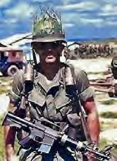
MAISEY, REGINAL VICTORY
CAPT - Air Force – Reserve (Air Force Cross) Age 33, Married Caucasian Male
Born NOV 17, 1934, From SONOMA, CA
Length of service 10 years.
His tour of duty began on 26 AUG 1967
BIEN HOA AIR BASE, REPUBLIC OF VIETNAM,3d AIR POLICE SQUADRON Casualty was on 31 JAN 1968 in BIEN HOA, SOUTH VIETNAM
HOSTILE, GROUND CASUALTY ARTILLERY, ROCKET, or MORTAR
Religion – ROMAN CATHOLIC. Body was recovered.
Panel 36E - Line 23.

Description (Combat): Battle of Bunker Hill-10, Bien Hoa Air Base. Capt. Maisey led Security Police Forces contributing to enemy KIA of 159 confirmed NVA. Bodies buried in mass grave. Decades later, Security Police helped identify the mass grave location, and the remains were returned to Vietnamese families by the joint Vietnam/U.S. recovery efforts.
*

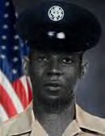
MC DONALD, RONALD IRVIN
A1C, Air Force – Regular Age 20, Male Black, Single, Born 21 MAY 1949
From New York City, NY.
His tour of duty began on 11 MAR 1970 Casualty was on 14 APR 1970
TAN SON NHUT AIR BASE, REPUBLIC OF VIETNAM, 377th SECURITY POLICE SQUADRON, K-9 Handler.
Casualty was on 14 APR 1970, In GIA DINH, Non-Hostile [LOD]: died of illness/injury, GROUND CASUALTY OTHER ACCIDENT.
Body was recovered. Panel 11W - Line 3.

Description: A1C Ronald I. McDonald, a K-9 sentry dog handler, assigned Blue Patrol, 377th Security Police Squadron, Tan Son Nhut Air Base, Gia Dinh Province, RVN On April 14, 1970, died from a brain-stem contusion suffered in the Line of duty.
*

MC KELVEY, WILLIAM R.
SGT - Air Force - Age 23, Male Born 30 JAN 1952
From PHILADELPHIA, PA
NAKHON PHANOM RTAFB, THAILAND, 56th SECURITY POLICE SQUADRON
Casualty was on 13 MAY 1975
Non-Hostile [LOD]: Helicopter Crash (Eighteen 56th SPS were Killed) (Mayaguez Rescue Operation, Cambodia, 12-15 MAY 1975)
Body was recovered. Panel 01W - Line 128.

Description: McKelvey was the last of the 630 servicemen from Philadelphia to die in the Vietnam Theater of Operations during the Vietnam Era, which the Department of Defense defines as the period from August 1964 through May 1975. The 23-year-old Air Force sergeant was killed when the from
CH-53 helicopter in which he was riding crashed thirty-five miles southwest of Nakhon Phanom, Thailand, on May 13, 1975. McKelvey had left Roxborough High School in 1969 at the age of seventeen to enlist. He was assigned to the 56th Security Police Squadron in Vietnam. McKelvey had married a Thai woman and planned to adopt her daughter. In addition to his wife, he was survived by his parents and a sister. William lived on DuPont Street, in Roxborough, (PA. Source: Philadelphia Daily News 10/26/1987, Saturday, December 20, 2003). Don Graham.
*

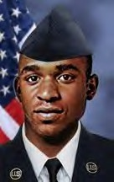
MCKNIGHT, CLARENCE
A1C - Air Force Age 23, Male Born July 10, 1949.
From Kingsport, TN
Casualty was on June 12, 1973, in THAILAND, 56th SPS, NKP Thailand, NKP Thailand RTAFB.
Non-Hostile [LOD]: GROUND CASUALTY ACCIDENTAL SELF-DESTRUCTION
(Gunshot wound in chest). Body was recovered.
*

MCNEILL, MICHAEL SIDNEY
A1C – E3 – Air Force -Regular Age 23, Caucasian Single Male Born 18 OCT 1949.
From OKULGEE, OK
Length of service 2 years
DA NANG AIR BASE, REPUBLIC OF VIETNAM,
6498th SECURITY POLICE SQUADRON in QUANG NAM, SOUTH VIETNAM
Casualty was on Dec 5, 1972
Non-Hostile [LOD]: GROUND CASUALTY ACCIDENTAL SELF-DESTRUCTION.
Religion – ROMAN CATHOLIC. Body was recovered.
Panel 01W – Line 93.
*

MIDKIFF, GARY BRUCE
SGT – E3 – Air Force – Regular
Age 22, Male Born 7 July 1945 From Miami, OK.
Length of service 2 years. His tour of duty began on 01 OCT 1967 BINH THUY AIR BASE, 632nd SECURITY POLICE SQUADRON
Casualty was on 4 FEB 1968 in PHONG DINH, SOUTH VIETNAM
HOSTILE, GROUND CASUALTY, ARTILLERY, ROCKET, or MORTAR.
Religion; Protestant. Body was recovered. Panel 37E – Line 25.

Description: Binh Thuy AB Sgt Gary Bruce Midkiff. A1C (E4) Gary Midkiff Killed In Action, Binh Thuy AB, 1968 Offensive: On Feb. 4, 1968, at approximately 2:00 a.m. the TET Offensive became a reality for Binh Thuy AB. The first casualty for the 632nd Security Police Squadron, during the 1968 Offensive, was Sgt Gary Midkiff. Gary was assigned to Alpha-2 post, which was a machine gun bunker.
*

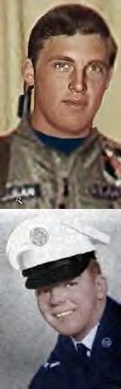
MILLIGAN, RANDALL GALE
A1C - Air Force - Regular
Age 20, Single Caucasian Male Born AUG 10, 1947
From LATON, CA
Length of service 1 year. His tour of duty began on 09 FEB 1968
CAM RANH BAY AIR BASE, REPUBLIC OF VIETNAM, 12th SECURITY POLICE
SQUADRON Casualty was on 13 MAY 1968 in KHANH HOA, SOUTH VIETNAM
Non-Hostile [LOD]: GROUND CASUALTY ILLNESS, DISEASE. Religion – BRETHREN (DUNKERS)
Body was recovered. Panel 60E - Line 27
*

MILLS, ROGER BERTHA
SGT – E4 – Air Force -Regular Age 21, Single Caucasian Male Born 30 Aug 1946
From HAVRE DE GRACE, MD
Length of service 3 years. His tour began on 29 Dec 1967
TAN SON NHUT AIR BASE, REPUBLIC OF VIETNAM, 377th SECURITY
POLICE SQUADRON Casualty was on 31 JAN 1968 in GIA DINH, SOUTH VIETNAM
HOSTILE, GROUND CASUALTY ARTILLERY, ROCKET, or MORTAR. Religion – BAPTIST - SOUTHRN.
Body was recovered. Panel 36E – Line 25
*

MORAN, EDGAR CRAIG, II
AIRMAN - Air Force Age 19, Male|
Born 16 FEB 1956 From PITTSBURG, PA
NAKHON PHANOM RTAFB, THAILAND, 56th SECURITY POLICE SQUADRON
Casualty was on 13 MAY 1975
Non-Hostile [LOD]: Helicopter Crash (Eighteen 56th SPS were Killed) (Mayaguez Rescue Operation, Cambodia, 12-15 MAY 1975)
Body was recovered. Panel 01W - Line 128
*

MORGAN, CHARLES R.
Sgt - Air Force Born 13 Feb 1920
NAKHON PHANOM RTAFB, THAILAND, 56th SECURITY POLICE SQUADRON
Casualty was on 08 DEC 1968. Body was recovered.
*

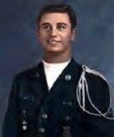
MOON, JERRY RUDOLPH
A2C - E3 - Air Force - Regular Age 21, Married Caucasian Male Born 10 APR 1946
From LANETT, AL
Length of service 2 years.
His tour of duty began on 25 DEC 1966
TUY HOA AIR BASE, REPUBLIC OF VIETNAM, 31st AIR POLICE SQUADRON
Casualty was on 07 SEP 1967 in PHU YEN, SOUTH VIETNAM
HOSTILE, GROUND CASUALTY - GUN, SMALL ARMS FIRE.
Body was recovered Panel 26E - Line 28.
*

MUSE, EDWARD GRADY
A1C - Air Force - Regular
Age 20, Single Caucasian, Male Born 04 OCT 1947
From TUTWILER, MS
Length of service 1 year.
His tour of duty began on 09 SEP 1967
BIEN HOA AIR BASE, REPUBLIC OF VIETNAM, 3d AIR POLICE SQUADRON (Augmentee)
Casualty was on 31 JAN 1968 in BIEN HOA, SOUTH VIETNAM
HOSTILE, GROUND CASUALTY ARTILLERY, ROCKET, or MORTAR
Religion CHURCH OF CHRIST Body was recovered.
Panel 36E - Line 27
*

NEALIS, TOMMY R.
SGT - Air Force Age 22, Male Born 23 APR 1953
From MT STERLING, CT
NAKHON PHANOM RTAFB, THAILAND, 56th SECURITY POLICE SQUADRON
Casualty was on 13 MAY 1975
Non-Hostile [LOD]: Helicopter Crash (Eighteen 56th SPS were Killed) (Mayaguez Rescue Operation, Cambodia, 12-15 MAY 1975).
Body was recovered Panel 01W - Line 128.
*

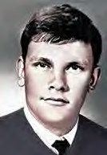
NEEL, ROBERT RAY
SGT - Air Force – Regular
Age 21, Single Caucasian Male
Born APR 12, 1948 - From HOUSTON, TX
His tour of duty began on 02 JUL 1969.
NHA TRANG AIR BASE, REPUBLIC OF VIETNAM, 14th AIR POLICE SQUADRON
Casualty was on 02 MAY 1970 in KHANH HOA, SOUTH VIETNAM Non-Hostile [LOD]: GROUND CASUALTY ACCIDENTAL HOMICIDE.
Religion – PENTECOSTAL.
Body was recovered. Panel 11W - Line 86.

Description: Gunshot/horseplay with weapons. From: CLIFFADIO@aol.com. Subject: VSPA: Memorial of AP/SP KIA or Line of Duty was just perusing the memorial and saw the entry for NEEL, Robert Ray was incomplete. Bobby was killed due to a weapons horseplay incident at CAM RANH BAY AIR BASE. He was on in- country R & R from the 14th or the 90th SECURITY POLICE SQUADRON at NHA TRANG, having departed PCS from CAM RANH BAY AIR BASE for NT earlier. Anyway, his memorial will be able to be complete now. Thanks, Clifford Wilson
*

NIX, JOHN DAVID
SGT- Air Force- Regular
Age 23, Married Caucasian Male
Born DEC 15, 1947 - From LOUISVILLE, KY
His tour of duty began on 01 JUN 1970, in GIA DINH, SOUTH VIETNAM.
PHAN RANG AIR BASE, REPUBLIC OF VIETNAM, 35th SECURITY POLICE SQUADRON
Casualty was on 25 APR 1971
Non-Hostile died of ILLNESS/INJURY GROUND CASUALTY VEHICLE CRASH.
Body was recovered. Panel 03W - Line 12.
Description: Jeep Crash.

*

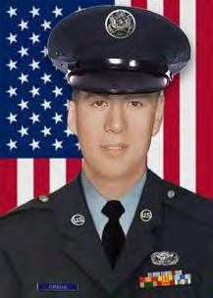
ORSUA, CHARLES DAVID
A1C - Air Force - Regular
Age 19, Single Caucasian Male
Born 19 APR 1950 - From SUNNYVALE, CA
His tour of duty began on 28 APR 1969, PHAN RANG AIR BASE, REPUBLIC OF VIETNAM, 35th SECURITY POLICE SQUADRON
Casualty was on 15 JUL 1969
in NINH THUAN, SOUTH VIETNAM.
Non-Hostile [LOD]: died of ILLNESS/INJURY GROUND CASUALTY VEHICLE CRASH
Religion - ROMAN CATHOLIC.
Body was recovered. Panel 20W - Line 2.
*Description: K-9 Truck rollover.

PACIO, GEORGE HENRY
A1C - Air Force - Regular
Age 23, Single Caucasian Male Born 15 MAR 1947
From LONG BEACH, NY
His tour of duty began on 27 OCT 1970
TAN SON NHUT AIR BASE, REPUBLIC OF VIETNAM, 377th SECURITY POLICE SQUADRON
Casualty was on DEC 21, 1970. in GIA DINH, SOUTH VIETNAM.
Non-Hostile [LOD]: GROUND CASUALTY ACCIDENTAL SELF-DESTRUCTION
Body was recovered
Religion – ROMAN CATHOLIC. Panel 06W - Line 135.
*

PACKER, JOSEPH EVERETT, JR.
A2C - E3 - Air Force – Regular Age 20, Single Caucasian Male Born 13 JUL 1945
From CAMDEN, NJ
Length of service 2 years.
His tour of duty began on 16 MAR 1966
DONG HA AIR BASE, REPUBLIC OF VIETNAM, 6250th AIR POLICE SQUADRON Casualty
was on 16 JUN 1966.
in QUANG TRI, SOUTH VIETNAM.
Non-Hostile [LOD]: GROUND CASUALTY, VEHICLE CRASH JEEP.
Body was recovered. Panel 08E - Line 53.

Description: Died JUN 16, 1966, Vehicle crash near Dong Ha AIR BASE, REPUBLIC OF VIETNAM, while on duty driving a weapons carrier and swerved to avoid hitting a Vietnamese woman. Was assigned to Dong Ha Air Base as base defense/security for the Air Force Det. 1, 620th TCS, Tactical Radar Squadron.
*

PALMER, ROBERT A.
Sgt - Air Force
NAKHON PHANOM RTAFB, THAILAND, 56th SECURITY POLICE SQUADRON
Casualty was on 07 MAY 1970
Non-Hostile [LOD]: ILLNESS/Disease. Body was recovered.
*

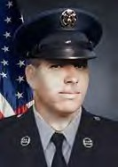
PARK, IRVING GEON
SGT Air Force - Regular
20 years old Single Caucasian Male
Born 06 DEC 1948. From FORT WAYNE, IN.
Length of service 2 years. His tour of duty began on 05 JAN 1969
PHU CAT AIR BASE, REPUBLIC OF VIETNAM, 37th AIR POLICE SQUADRON Casualty was on 03 JUN 1970, in BINHDINH, SOUTH VIETNAM.
Non-Hostile [LOD]: GROUND CASUALTY VEHICLE CRASH.
Religion – PROTESTANT.
Body was recovered - Panel 13W - Line 88.

Description: K-9 Truck rollover.
*

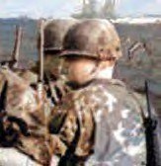
PASCOE, ROBERT EDWARD
A1C - Air Force - Regular
Age 24, Married Caucasian Male
Born 17 APR 1943. From ARLINGTON, VA. PLEIKU AIR BASE, 633d AIR POLICE SQUADRON
Casualty was on 18 JUL 1967, in PLEIKU, SOUTH VIETNAM. Non-Hostile [LOD]: GROUND CASUALTY OTHER ACCIDENT.
Body was recovered. Panel 23E - Line 88.

Description: Accidental Grenade/Armory Explosion.
*

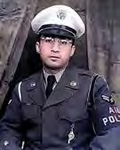
PEREZ, CARLOS AUGUSTO
SGT - Air Force – Regular
Age 35, Single Caucasian Male
Born JUN 01, 1932. From AGUADILLA, PR.
Length of service 16 years.
His tour of duty began on APR 17, 1967, PLEIKU AIR BASE, 633d AIR POLICE SQUADRON
Casualty was on 01 DEC 1967, in PLEIKU, SOUTH VIETNAM Non-Hostile [LOD]: GROUND CASUALTY ILLNESS, DISEASE.
Religion - ROMAN CATHOLIC.
Body was recovered. Panel 31E - Line 22.
*

PETERSON, RUFUS G., JR.
A1C – Air Force – Regular. Age 21, Born 22 JUN 1951
633d AIR POLICE SQUADRON, PLEIKU AIR BASE.
Casualty was on 19 NOV 1971.
Non-Hostile [LOD]: Drowned: Lake Suan Kaset Lingsun, Udorn RTAFB, Thailand. Body was recovered.
Burial: Garland Community Cemetery, Garland, NC.
*

PINER, JOHN ROBERT
SGT - Air Force - Regular Age 21, Single Caucasian Male Born MAY 08, 1948
From SAN GABRIEL, CA
Length of service 2 years.
His tour of duty began on 17 APR 1969
TAN SON NHUT AIR BASE, REPUBLIC OF VIETNAM, 377th SECURITY POLICE SQUADRON
Casualty was on 11 MAR 1970,
in BIEN HOA, SOUTH VIETNAM Non-Hostile [LOD]: GROUND CASUALTY ILLNESS, DISEASE
Body was recovered Religion – METHODIST. Panel 13W - Line 113
*

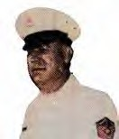
POROVICH, STEVE
SMSGT - Air Force-Regular Married Male Caucasian Age 47, Male.
Born NOV 03, 1924,From TUCSON, AZ
His tour of duty began on 15 JAN 1972
TAN SON NHUT AIR BASE, REPUBLIC OF VIETNAM, 377th SECURITY POLICE SQUADRON
Casualty was on 21 APR 1972 in GIA DINH, SOUTH VIETNAM
Non-Hostile [LOD]: died of ILLNESS/INJURY GROUND, CASUALTY HEART ATTACK
Body was recovered.
Religion - RUSSIAN ORTHODOX.
Panel 01W - Line 5.
*

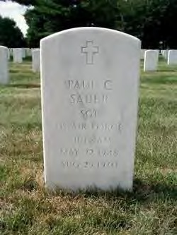
SAUER, PAUL C.
Sgt - Air Force. Age 22, Male. Born 22 MAY 1948. From NEW YORK CITY, NY
Casualty was on 25 AUG 1970
DON MUANG RTAFB, THAILAND, 631st SECURITY POLICE SQUADRON
NON-HOSTILE - Body was recovered.

Description: Non-Hostile, Train vs. Vehicle. The New York Times, 1996 BANGKOK, Thailand, Aug. 26 (Reuters) — An express train traveling at full speed struck bus, killing seven American Airmen, and injuring four others at a railroad crossing near Bangkok's Don Muang airport, police sources said today. The bus was taking the airmen to their headquarters from the airport fifteen miles north of Bangkok last night when the collision occurred at an unguarded crossing, the police said. The police identified the dead Airmen as Thomas J. Broad water, Age 26, Handel Emila Jr., 26; Paul C. Saver, 22; Richard H. Stanton; 40; Walter Krizanowski, 24; Richard Gregsby, 21, and Paul Edmunson,22.
*

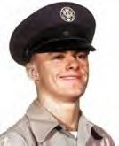
RIDDLE, OLIVER JOHN
A2C - Air Force – Regular
Age 21, Single Caucasian Male
Born 23 OCT 1945. From CORAOPOLIS, PA
Length of service 2 years.
His tour of duty began on 29 NOV 1966
TAN SON NHUT AIR BASE, REPUBLIC OFVIETNAM, 377th SECURITY POLICE SQUADRON
Casualty was on 04 DEC 1966. in GIA DINH, SOUTH VIETNAM.
HOSTILE, GROUND CASUALTY ARTILLERY, ROCKET, or MORTAR
Body was recovered. Panel 13E - Line 12.

Description and Info: I have a few photos of the grave of A2C Oliver Riddle. I was hoping you could add them to the link and story about him. He is buried in
the military section of Holy Souls Cemetery in Robinson Township, Pa. MSgt Pat Riley, 171st SFS, PA.
*

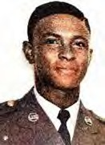
ROBERTSON, ROBERT MERLIN
SGT - Air Force – Regular Age 22, Married Negro Male
Born 20 MAY 1947. From RALEIGH, NC
Length of service 2 years.
His tour of duty began on 20 MAY 1969.
NAKHON PHANOM RTAFB, THAILAND, 56th SECURITY POLICE SQUADRON
Casualty was on 27 JAN 1970.
Non-Hostile, died of ILLNESS/INJURY, GROUND CASUALTY - HEART ATTACK. Religion - UNITED CHURCH OF CHRIST.
Body was recovered. Panel 12W – Line 103.
*

ROSS, ROBERT W.
SGT - Air Force - Age 20, Male
Born 09 JUL 1954. From CYPRESS, CA
NAKHON PHANOM RTAFB, THAILAND, 56th SECURITY POLICE SQUADRON
Casualty was on 13 MAY 1975.
Non-Hostile, Helicopter Crash (Eighteen 56th SPS were Killed) (Mayaguez Rescue Operation, Cambodia,12-15MAY 1975) Body was recovered.
Panel 01W - Line129

*

SISLEY, RUSSELL JAY
SMSgt- E8 - Air Force – Regular Age 38, Married Caucasian Male
Born 30 NOV 1927. From CARTER LAKE, IA
Length of service18 years.
His tour of duty began on 24 JAN 1966, in QUANG TRI PROVINCE,
DONG HA AIR BASE, REPUBLIC OF VIETNAM, 6250th AIR POLICE SQUADRON Casualty was on 16 JUN 1966 in QUANG TRI, SOUTH VIETNAM.
NON-HOSTILE, GROUND CASUALTY, WEAPONS CARRIER CRASH.
Body was recovered - Panel 08E - Line 54.

Description: Died JUN 16, 1966, Vehicle crash near Dong Ha AIR BASE, REPUBLICOF VIETNAM, while on duty driving a weapons carrier and swerved to avoid hitting a Vietnamese woman. Was assigned to Dong Ha Airfield as base defense/security for the Air Force 620th Tactical Radar Squadron. May have TDY to Dong Ha Air Base.
*

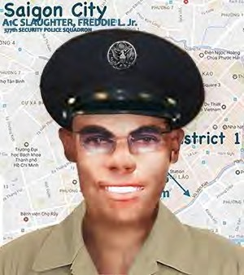
SLAUGHTER, FREDDIE L., JR.
A1C - Air Force – Regular Age 20, Single, Negro, Male
Born 14 JUL 1952. From JACKSON, MS
His tour of duty began on 17 MAR 1972.
TAN SON NHUT AIR BASE, REPUBLIC OF VIETNAM, 377tjh SECURITY POLICE SQUADRON
Casualty was on 30 JUL 1972, in GIA DINH, SOUTH VIETNAM Non-Hostile, GROUND CASUALTY DROWNED, SUFFOCATED
Religion – BAPTIST
Body was recovered - Panel 01W - Line 61

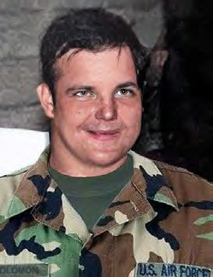
*
SOLOMON, SIDNEY MORTON
SSGT - E5 - Air Force – Regular (Korea; Vietnam) Age 39, Married Caucasian Male
Born 08 NOV 1930. From Roslyn Heights, NY His tour of duty began on 28 JAN 1970
BINH TUY AIR BASE, REPUBLIC OF VIETNAM, 632nd SECURITY POLICE SQUADRON
Casualty was on 16 MAY 1970.
Non-Hostile, Ground Casualty - Vehicle Crash Religion – Jewish
Body was recovered. Panel 10W - Line 54.

Description: The accident claimed the lives of two SPs on their way to post and were hit by a drunk driver, driving a deuce and a half.
*

STEEN, LENORD LARRY
A1C – Air Force - Regular
UBON RTAFB, THAILAND, 8th AIR POLICE SQUADRON
08 OCT 1967 Non-Hostile [LOD]: Gunshot. Body was recovered.
*

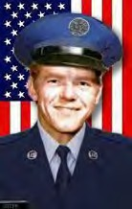
STEPP, CHARLES HAROLD
A1C - Air Force - Regular
Age 18, Single Caucasian Male Born FEB 12, 1954
From POPLAR BLUFF, MO
His tour of duty began on JAN 01, 1972
DA NANG AIR BASE, REPUBLIC OF VIETNAM, 6498th SECURITY POLICE SQUADRON Casualty was on SEP 05, 1972, in QUANG NAM, SOUTH VIETNAM,
Non-Hostile, GROUND CASUALTY ACCIDENTAL SELF DESTRUCTION (Gunshot wound in the chest) Religion – BAPTIST
Body was recovered Panel 01W -Line 70
*

STEWART, ERIC V. V. D.
U-TAPAO RTAFB, T HAIL AND, 635t h SEC URI TY P OLI CE S QUADRON
Casualty was on 09 DEC 1970. Non-Hostile [LOD]: Vehicle Crash. Body was recovered.
*

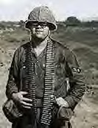
WILLIS, THOMAS MURTEN
A2C - E3 - Air Force – Regular Age 20, Single Caucasian Male Born 03 OCT 1946
From MC CALL, ID
Length of service 3 years.
His tour of duty began on MAY 02, 1966
PHAN RANG AIR BASE, REPUBLIC OF VIETNAM, 35th SECURITY POLICE SQUADRON Casualty was on JUN 05, 1967, in QUANG TRI, SOUTH VIETNAM.
Non-Hostile, died of ILLNESS/INJURY, GROUND CASUALTY ILLNESS, DISEASE. Body
was recovered. Panel 21E - Line 59.
*

SUPNET, RICHARD ARELLANO
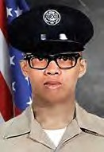
A1C - Air Force – Regular
Age 19, Single, Malayan, Male
Born MAR 17, 1952- From SAN FRANCISCO, CA
His tour of duty began on JAN 07, 1971
CAM RANH BAY AIR BASE, REPUBLIC OF VIETNAM, 483rd SECURITY POLICE SQUADRON
Casualty was on SEP 23, 1971
in KHANH HOA, SOUTH VIETNAM.
Non-Hostile GROUND CASUALTY, ACCIDENTAL SELF-DESTRUCTION.
Religion - ROMAN CATHOLIC. Body was recovered.
Panel 02W - Line 24.
Description: Accidental Self-Destruction (Gunshot: dropped his weapon).
*

TREEN, HARLIN PERRY
MAJ - Air Force -Regular Age 39, Married, Caucasian, Male
Born MAY 10, 1929
From ENID, Garfield County, OKLAHOMA Length of service 20 years.
His tour of duty began on APR 25, 1968,TAN SON NHUT AIR BASE, 377th CSG
Casualty was on AUG 12, 1968,in GIA DINH, SOUTH VIETNAM,
Non-Hostile, GROUND CASUALTY ACCIDENTAL SELF-DESTRUCTION
Body was recovered. Religion - BAPTIST Panel 48W - Line 4
*

WEBB, ROBERT C.
MSgt - Air Force
UDORN RTAFB, THAILAND, 432nd SECURITY POLICE SQUADRON
Casualty was on 18 NOV 1968
Non-Hostile [LOD]: ILLNESS/Disease. Body was recovered.
*

WHITFIELD, JESSE J.
Sgt - Air Force
UDORN RTAFB, THAILAND, 432nd SECURITY.
08 OCT 1970 Non-Hostile. Body was Recovered.

Description: Accidental Self-Destruction: Gunshot – I am not a member of VSPA, but I am well aware of one of our fallen that you have listed on your website. I was a Security Policeman for 22 years and retired as a MSgt on 1 JUN 1989. I was Sgt. Jesse Whitfield’s Flight Chief at the time of his death.
At the time his death occurred, he was assigned to Det-1, 432nd SECURITY POLICE SQUADRON (Nam Phong Airfield, Thailand). Our TDY site was located 60-70 miles south of our main base at Udorn RTAFB. Jesse was a quiet, yet humorous young man. He bunked in the same trailer as I did. His room was right next to mine. I do not know what compelled Jesse to do what he did on that fateful night, but; I will never understand why.
He was a "good" troop. He never gave any indication that were any problems in his life. If there were problems, he hid them well. As I said earlier, Jesse was a good man and a fine 'Security Policeman.' I cannot give anyone any answers. All I can say is that Sgt. Jesse Whitfield performed his duties in an outstanding manner, and whatever his persona problems may have been, they didn't detract from his dedication to his duties. Bill McGeorge, Sgt (USAFRET.)
*

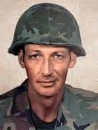
WISSIG, EDWARD SIMON
SSGT - E5 - Air Force – Regular Age 39, Caucasian Male Married Born 24 May 1931
From LAKE RONKONKOMA, NY
His tour began on Jul 31, 1970.
PHU CAT AIR BASE, 12th SPS, SOUTH VIETNAM
Casualty was on Feb 12, 1971, In
BINH DINH, SOUTH VIETNAM.
HOSTILE, GROUND CASUALTY OTHER EXPLOSIVE DEVICE.
Religion – ROMAN CATHOLIC. Body was recovered.
Panel 05W - Line 100.
*

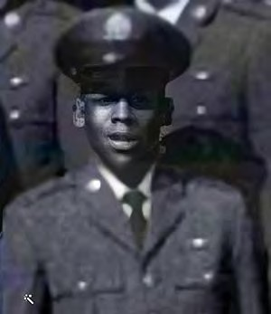
WOOD, BERTRAM, JR.
A1C - Air Force – Regular Age 20, Single, Negro, Male
Born 30 OCT 1949. From BALTIMORE, MARYLAND
His tour of duty began on 04 JUN 1970
PLEIKU AIR BASE, 6254th APB/Security POLICE SQUADRON
Casualty was on 25 SEP 1970 in KHANH HOA, SOUTH VIETNAM Non-Hostile, GROUND CASUALTY, ACCIDENTAL SELF-DESTRUCTION
Religion – BAPTIST Body was recovered Panel: 07W–Line 88.
*

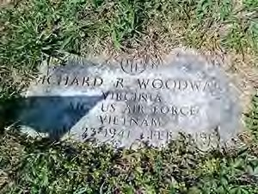
WOODWARD, RICHARD RANDOLPH
A1C - Air Force – Regular Age 24, Single, Negro, Male
Born 23 APR 1941. From SPOTSYLVANIA, VA
Length of service 6 years.
His tour of duty began on 04 FEB 1966
DA NANG AIR BASE, REPUBLIC OF VIETNAM, 6252nd AIR POLICE
SQUADRON Casualty was on 08 FEB 1966 in GIA DINH, SOUTH VIETNAM
Non-Hostile, died of ILLNESS/INJURY GROUND CASUALTY ILLNESS, DISEASE
Body was recovered Panel 05E - Line 19.
*

In Memory of Jackie Kays (RIP-111 10/13/2020), Warrior, Poet, Hero, Friend.
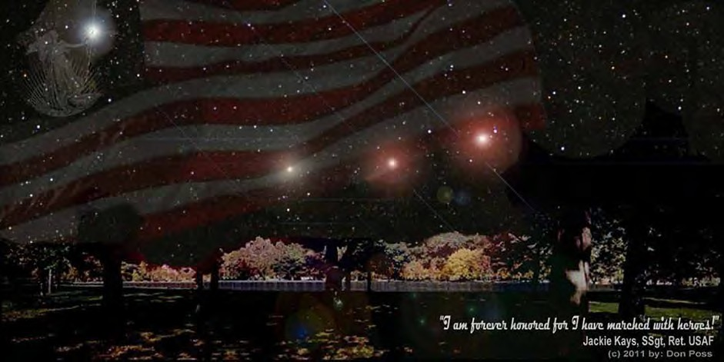
Names of 58,212 Killed in Action or Line of Duty are inscribed in the black granite Wall, at rest beneath a blanket of starlight and flares. SSgt Jackie Kays (Ret. USAF, Da Nang AB, 1965, RIP Sep 2020) said it best: I am forever honored, for I have marched with heroes. (c) Photo & Composite 2011, by Don Poss.
We Take Care of Our Own

