Vietnam Security Police Association
VIETNAM MEMORIAL SERVICE
OCTOBER 8, 2021
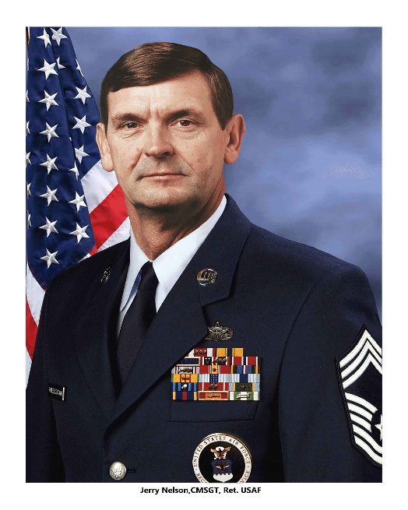
Good afternoon, it is an honor to welcome you to the Southeast Asia Pavilion on the Grounds of the United States Air Force Academy.

CHAPLAIN JIM STASTNY, please come forward for the invocation PRAYER.

Thank you for the prayer, Jim.

This wonderful venue was created as a tribute to the Air Force Academy graduates who served in the Vietnam War. The pavilion was spearheaded by the Air Force Academy Class of 1970, as a permanent memorial to those men and women who served in Vietnam and Thailand. Other classes have joined in that endeavor to ensure that the facility is properly maintained. At the conclusion of our memorial service, I encourage everyone to walk through the pavilion to see the honored history of the graduates who are Vietnam Veterans, and feel the spectacular manner in which the facility tells that story.

The following words were written as a Tribute to the Vietnam Security Police Association on the occasion of our Reunion, October 12, 2002:

“Men who served together in good and bad times…, who gave themselves unselfishly to their country…, to their unit and to their mission…; men who stand in later years with hand over heart when the flag of America passes in review…; men whose affection for one another forged lasting bonds of respect and friendship…; these men are the core and heart of our country… They are AMERICA!

Be quietly proud of yourselves and of each other... Take warmth from the ties that bind each of you to the other.

I am humbly proud to have served with men like you.

Robin Olds, Brigadier General,
United Stated Air Force (Retired),
Commander, 8th Tactical FigJhter Wing.”

Brigadier General Olds was a giant of a man and one of the most recognized pilots in United States Air Force history. During his tenure, he was a three-time Ace in World War II, Korea, and Vietnam where he shot down 17 enemy planes. He was one of our wing commanders at Ubon Royal Thai Air Force Base, Thailand, where he pioneered the Wild Weasel Program. He was also the Commandant of Cadets at this Academy from 1967-1971. Earlier today, we were able to spend some time at a Bronze statue of General Olds that was just recently completed. His letter certainly sums up, in a few words, the bonds that hold our Brotherhood together. In the civilian sector, those feelings of love and pride do not exist in other relationships unless you are in law enforcement or the fire service. As you know, on Wednesday evening, we read the names of our 32 Brothers who stood their final Guardmount; and the 3 Sisters who passed since our last reunion. We will always honor and respect their lives and sacrifice… as we should, as we all have benefitted from their friendship and sacrifice. Our brothers are now remembered forever in our Life Member #111… and we will always remember them as well as the members of our Sisterhood.

Today, we also honor someone else entirely. This ceremony celebrates a group of Air Policemen, Security Policemen and Augmentees who answered their nation’s call, then served and fought at locations through Thailand and Vietnam. They served in Law Enforcement, Security, K-9 and or Safeside. They performed magnificently and never allowed an Air Force base or any other location to be overrun or taken. That is our legacy, our proud history…the history of YOUR service and I am proud to call you Brothers. I am talking about YOU!

There were more than 2.7 million military personnel who served in South East Asia.

Of those, over 303,000 were wounded.

2,338 personnel were Missing In Action. And 1,900 are still unaccounted for.

The United States Air Force had over 20,000 Air Policemen and Security Policemen who served in Thailand and Vietnam, with approximately 500 wounded. Our country suffered over 58,000 Deaths of US troops in the Vietnam War. And as you know, the Security Police career field suffered 112 deaths.

The Vietnam Conflict was the first war that was brought into the living rooms of America via television. I remember talking with my Mother, prior to her death and asked what it was like having a child in Vietnam… and what was she thinking…...She said it was horrible! She watched the national nightly newscast, hoping and praying that she would not see me on a stretcher being loaded onto a helicopter. I am certain that all of our parents had the same horrifying experience. This war divided America and resulted in an anti-military attitude among many of our citizens. We all remember what it was like when we returned to America… with people calling us baby killers, spitting on us, and shouting horrible things about us. I remember returning to Elba, a small south Alabama community. Even my close, lifelong friends were stand-offish and treated me differently. It took time for them to realize that I was the same guy they thought they knew. Little did they realize; and I certainly could not explain…why that was not the truth!

As you all know, we left the shores of Vietnam to return to what we called The World…to reunite with our families and loved ones.

However, Vietnam came home with us. The truth is, we did not recognize how much Vietnam and Thailand would remain a part of our lives. For many of us, our lives were changed forever. We were not the immature young men who had volunteered to serve our nation. We were forced to grow up in a hurry and do things unimaginable only months, and sometimes mere days before returning home.

What was the name for what had changed us, and why were so many veterans effected? Throughout our nation’s history it was called by several names: In the Revolutionary War, Nostalgia; Civil War, a Soldier’s Heart, or war-neurosis; WWI, Shell Shock; WWII Battle or Combat Fatigue; Korean War, Gross Stress Reaction. But PTSD, as it is known today, remained unnamed during the entire Vietnam War.

Vietnam War veterans returned home. Many of us did not carry visible physical wounds; but were suffering from an undefined disorder, and Marked by The Sword. Years after war’s end, “PTSD” first became the official name, as diagnosis in 1980, and included in the Anxiety Disorders section of the DSM-III psychiatric manual.

Nevertheless, the Veterans Administration denied the validity of both PTSD and Agent Orange related illnesses, although those tolls on Vietnam War veterans continued unabated. Most of us were too proud to admit we were suffering from nightmares, hypervigilance, or a form of mental illness, refused treatment, suffering in silence, or acknowledging the existence of PTSD for years. That happened because of a stigma attached to a Diagnosis of PTSD – the “D” very notably indicating the word “DISORDER.” Thank goodness that has changed. Unfortunately, the result was strained relationships, divorces and very difficult lives led by many veterans. I am proud to say, that today, things are much different. Social awareness of Post Traumatic Stress, advanced treatment and Veteran’s understanding of VA treatment availability has resulted in many, many more seeking treatment ... and that includes suicide prevention. If anyone has not sought treatment, I urge you to pursue it. It will certainly change your life.

We also brought the war home in the form of Agent Orange and its many related diseases. Far too many of us suffer from the effects of Agent Orange. Every year, the VSPA briefs on the various diseases that we have as a result of our exposure. Our own government would not acknowledge Agent Orange diseases for many, many years. While that was a constant problem, and often troubled our members, especially as it relates to proof of exposure, they fully realize and admit their responsibility now. If you are suffering, I encourage you to contact a Veteran’s Service Officer, seek assistance and file a claim with the VA.

While we have all endured hardship and have experienced multiple issues related to our service in Vietnam and Thailand, I am so very proud of you, and absolutely proud to call you, my Brothers. We have all sacrificed in some way and answered our Nation’s call. You were absolutely the best America had, then and now. I am so honored to be in this distinguished group. The letter by General Olds, which I read earlier, describes you perfectly!

There is another special group that I need to honor today. They are those who are committed to their motto: “Taking care of those who take care of their own.” They live that motto on a daily basis, 24 hours a day, day after day, year after year. They stood by us, raised our children, paid our bills, and waited for us to come home. For those who found us later in life, sometimes broken and in need of healing, they loved us and have taken care of us as we take care of our own, as we sought treatment for Agent Orange related cancer, and Post Traumatic Stress.

Our Sisterhood is a wonderful group of wives and companions, who care for us, hold our hand in the night, listen to us cry out with nightmares, and help us function when it seems like we can’t make it through the night, or the next day. They push us in wheelchairs and always stand by our side whenever things go sideways. When things go dark, they are there holding things together, helping us realize we are going to be okay. They are our biggest supporters and sometimes need to give us the guidance that saves us. I can readily admit that without my spouse’s love and support, I would have suffered a far worse outcome in this life after the war. I know that I am not alone. The Sisterhood is our backbone. Thank God for their support. It is hard to imagine how many of us would have dealt with life without them. Thank all of you for your love and support. We could not have survived this road without you. You are an amazing group!

Our journey as Veterans of Vietnam and Thailand is not over. According to the latest statistics, we still have over 500,000 surviving Veterans who served in Vietnam and Thailand. In this group alone, we have well over thirteen hundred Veterans of that war. We have many who served multiple tours and some who served in both countries. We must continue to preserve our history, tell our stories, and serve our nation in any capacity possible. I am proud of my Vietnam service, and I know all my Brothers are as well. I am looking forward to many more reunions with the VSPA because this is certainly not our last rodeo.

In closing, I would like to read a poem written by one of our VSPA Brothers, Randy “RAMPS” Stutler who was unable to attend the reunion this year. He wrote these words on July 19, 2008. It is titled:
“ONE MORE RIVER TO CROSS”
Echoes softly calling now, within my heart I hear
Loved ones who have passed away, and many friends so dear.

When we were young and fearless, we’d never count the cost.
Life’s challenge was no great thing, just one more river to cross.

In Vietnam we stood our ground, young troopers’ side by side.
We bit our lips and hid our fears, and honored those who died.

Through all the years of pain and sorrow, time extracts its cost,
And mortals we are bound to pay, one more river to cross.

Oh, if I could just go back to the way we were back then,
Laughing, living, full of life, proud warriors, and brave men.

But I know deep within my soul, as I count the friends I’ve lost,
There too lies ahead for me, one more river to cross.

Now, I ask HOWARD YATES, bagpipes, who will pipe AMAZING GRACE, and CHAPLAIN JEFF KERKHOFF, who will give our closing prayer, to come forward.

Thank you.

This concludes our ceremony; please enjoy the South East Asia Pavilion. We will board buses again in approximately one hour.

