- Copyright info for VSPA.com:
© 1995-2023, Vietnam Security Police Association, Inc. (USAF);
Incorporated as a 501(c)(19) Tax Exempt (nonprofit Veterans Organization. All Rights Reserved.
2. How to copy list of file and folder names in Windows 11/10
Follow these methods to copy the names into a clipboard or notepad, or Excel file:
1] Using Windows Explorer
- Go to the folder in which you want to copy the names using Explorer.
- If you want a complete list, use Ctrl + A to select all or select required folders.
- Click on the Home tab on the top menu, and then click on Copy Path.
- Finally, open Notepad or Excel or any text and paste.
- You should now see a full list, including the exact pathname.
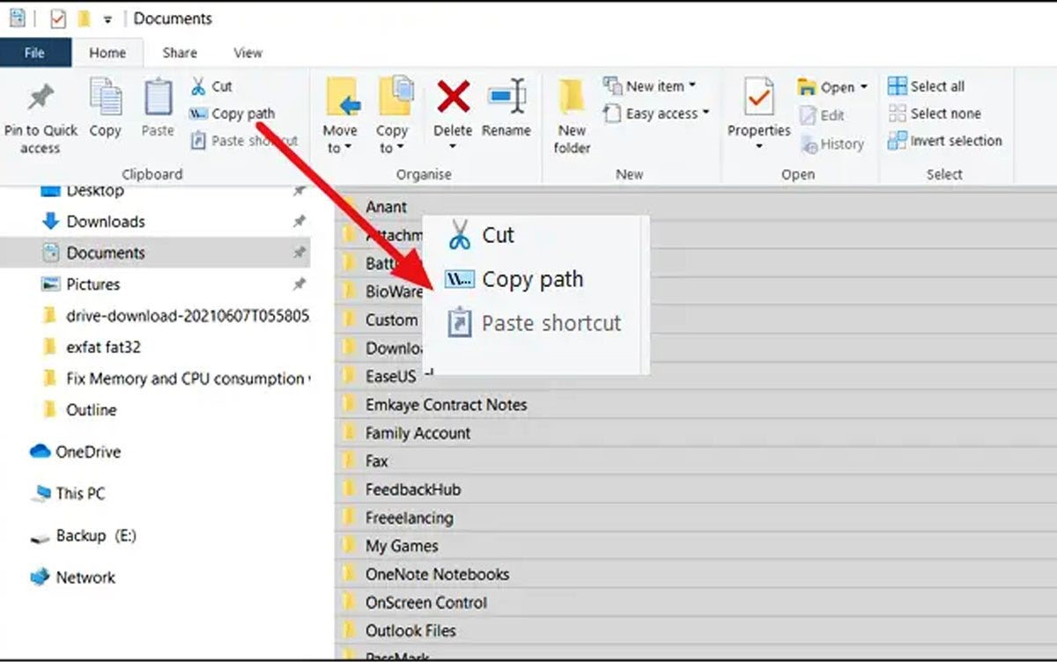
—-
What does it mean if the Unhide option is gray?
If the Unhide option in your Format list is gray, that means it's unavailable. This means you may be working on a protected worksheet. Navigate to Review, select Changes and if you see Unprotect Sheet, select it. This typically makes the Unhide button available for you to click. If you're already working on an unprotected worksheet, a gray Unhide button could also indicate that there are no hidden items to unhide.
—

Unhide all rows
There are a few methods that you can use to unhide all of your rows on your Excel spreadsheet. Here are some of the common ways you can try:

Use the select all button
In the top left corner of your spreadsheet, there's a triangle icon in between the first row and A column. Clicking on this icon, select the entire spreadsheet, click on the Home tab, Format icon and select to unhide rows from the drop-down menu that appears.

Use keyboard shortcuts
Depending on your operating system, you can use the keyboard shortcuts Ctrl + A or Command + A to select the entire document. Then you can press Ctrl + Shift + 9 to unhide all rows on your spreadsheet.

Use the context menu
You can select a set of rows between any range by clicking on the row you want to start with and press Ctrl as you click on the last row in your range. From there, you can right click on your selection and click on the function called Unhide.
—-
EXCEL:
Home – Format —Visibility ——UnHide & Hide——-[Select options to Hide/Unhide Rows/Columns:

